|  |  |
| --- | --- |
| C:\Users\Manjunath.Badiger\Pictures\tatatechnologies.jpg  Rmdv depolyment procedure  Steps for deployment of RMDV on premises. | Abstract  Detailed instructions about the deployment of RMDV on premises.  Malik, Neeraj |

**CONTENTS**

**1. Installation of WebSphere Application Server. 3**

**1.1 Steps for Installation: - 3**

**1.2 Manage profile of WAS. 5**

**2. Installation of CLM Applications. 5**

**2.1 Install JTS, CCM, QM Application. 5**

**2.2 Set up the database 6**

**3. Configuration of CLM Application with WAS. 9**

**3.1 Configuration of WAS with LDAP 10**

**3.2 Configuration of CLM with WAS ND & IBM HTTP Server. 24**

**Overview of WebSphere Topology 24**

**Create the Deployment Manager 26**

**Create the application server and proxy node agents 27**

**Creating the Web Server Definition 28**

**Creating Application Servers 31**

**Deploying the CLM applications 35**

**Starting and setting up CLM 37**

**4. Installation of Rational DOORS 39**

**4.1 Install Rational DOORS. 39**

# Installation of WebSphere Application Server.

* Install WebSphere Application Server & manage the profile in WAS.

## Steps for Installation: -

Assumptions:

* You have installed IBM Installation Manager 1.6.2 to the server on which WebSphere 7.0 resides.
* You have downloaded the Passport Advantage Packages for Installation Manager and WebSphere Application Server ND for Maximo and Smart Cloud Control Desk. Download [this](https://www.ibm.com/developerworks/community/groups/service/html/communityview?communityUuid=a9ba1efe-b731-4317-9724-a181d6155e3a#fullpageWidgetId=W5f281fe58c09_49c7_9fa4_e094f86b7e98&file=a179afee-c9c0-4252-b130-85e3dc04e336) for a visual representation of the packages you will need to download
* You have combined the two sets of three packages into two folders - called (say) WAS_ND_V8.5.5 and WAS_V8.5.5_SUPPL.

1. Launch Installation Manager

2. From the File Menu, select **Preferences**. The first item is **Repositories**.  
The Repositories page opens and shows available repositories, repository locations, and the connection status for the repositories. Click **Add Repository**. Click Browse. When you browse, go to the repository location (either the three WAS Network Deployment V8.5.5 downloads or the WAS V8.5.5 Supplements) and select the repository.config.

3. Add a second Repository for the other repository location

[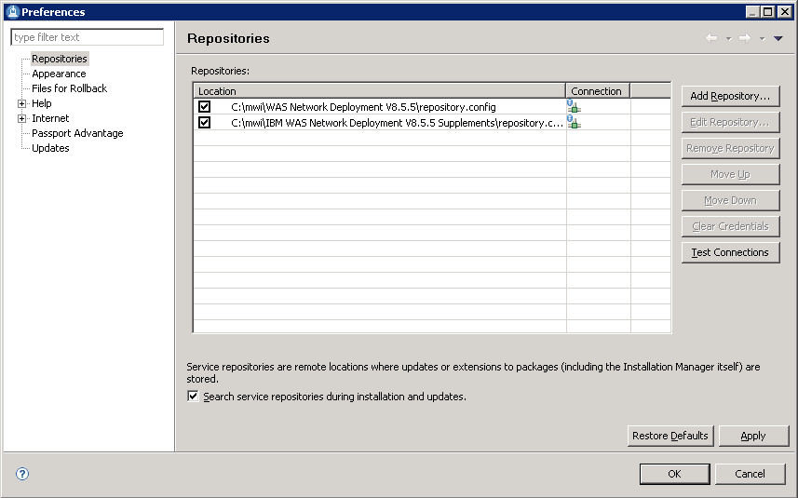](https://www.ibm.com/developerworks/community/blogs/a9ba1efe-b731-4317-9724-a181d6155e3a/resource/BLOGS_UPLOADED_IMAGES/Repositories.jpg)

4. Click **Apply**.

5. On the IBM Installation Manager screen, click Install.

6. Select everything. Click Next.

7. Accept the terms and click Next.

8. At the next four Install Packages screens, click Next.

9. On the **Configuration for IBM HTTP Server for WebSphere Application Server 8.5.5.0** screen: If you recall from previous blog posts, I disabled all of the existing WAS 7.0 services. So, port 80 will be available. Click Next.

10. At **Configuration for Application Client for IBM WebSphere Application Server 8.5.5.0**, change Host name to a fully-qualified host name (for example, maxprodtest.pontiac.ibm.com) and click Next.

11. Click Next. Install with Oracle Java JDK 1.6 (not Java 1.7 or later), for example:

* C:\Program Files (x86)\Java\jdk1.6.0_45\jre
* C:\Program Files (x86)\Java\jdk1.6.0_45
* C:\Program Files\Java\jdk1.6.0_45\jre
* C:\Program Files \Java\jdk1.6.0_45

12. Click Next.

13. At install Packages, click Install.

14. This will take a while. When it completes, click Finish.

15. Exit out of IBM Installation Manager.

## Manage profile of WAS.

# Installation of CLM Applications.

* Install CLM application on each WAS profile machines.
* Installation of DB2

## Install JTS, CCM, QM Application.

Before starting the installation, make sure these tasks are completed:

To install the servers and applications for the Rational solution for Collaborative Lifecycle Management (CLM), you must obtain the installation files. You can download either the Web Installer or the Installation Manager repository package for your platform from Jazz.net download section

(https://jazz.net/downloads/).

About this task

There are two ways to download and install CLM applications. The first installation method is a web based

installation that includes a smaller download and connects

to the Internet during the installation to get the repository files. If you must install the server in an environment without Internet access, use the second installation

method: download and extract the repository files to a local computer to install the server.

Procedure

a. Extract the downloaded .zip file to a temporary directory. To avoid issues, do not use long paths and directories that have spaces in their names.

b. Install by using either the web installer or the Installation Manager repository package.

To install by using the web installer:

i. Open the directory that you extracted the .zip file to, and run the launchpad executable file. The launchpad opens.

Note: If you want to install the product as a no administrator

user, from the Select user mode for Installation Manager list, select Non Administrator.

When you select Non Administrator,

the software packages will be installed in the user's directory and the package group will

be named My IBM Collaborative Lifecycle Management. Also on Windows operating systems with User Access Control (UAC) enabled, the

user who is installing the applications must be able to write to the installation directories.

ii. Follow the steps in the Launchpad to continue the installation. As you follow the steps in the Launchpad, Installation Manager opens to install the

software packages.

To install by using the Installation Manager repository package:

i. Start Installation Manager.

If you do not have a supported version of Installation Manager, you can obtain it from Jazz.net (https://jazz.net/downloads/ibminstallationmanager)

or download the web installer, which includes Installation Manager.

ii. Click File > Preferences, and then select Add Repository.

iii. To specify the repository location, browse to the directory where you downloaded the .zip file and open the repository.config file.

iv. Click OK, and then click Install to start the installation process.

v. Follow the instructions in Installation Manager to install the software packages.

c. During installation, clear Install with WAS Liberty Profile 8.5.x and select the Install application WAR files check box. This is to ensure that the

application WAR files are copied in the default webapps directory for later deployment. You can also choose a directory of your choice to copy the WAR files.

## Set up the database

The Rational solution for Collaborative Lifecycle Management products support IBM DB2 Enterprise Server Edition. For platforms that do not support Enterprise

Server Edition, you can use IBM DB2 Workgroup Server Edition. You can obtain a trial download of one these DB2 editions or the free DB2 Express Server edition

for deployments of 50 developers or fewer from ibm.com (http://www.ibm.com) .

Before you begin

This procedure requires that the following prerequisites are met:

The databases are not partitioned. Partitioned databases are not supported in this release and must not be used.

You have the correct user password.

You have reviewed the DB2 documentation to verify that your system meets the requirements and is configured correctly.

DB2 is installed and running on a computer to be used as the database server. This computer can be different from the one that the Jazz Team Server runs on Procedure

a. Open a DB2 command window.

b. Enter this command to create a database for Jazz Team Server called JTS with 16K pages and the UTF8

code set:

db2 create database JTS using codeset UTF8 territory en PAGESIZE 16384

c. Enter this command to create a database for Change and Configuration Management application called CCM with 16K pages and the UTF8

code set:

db2 create database CCM using codeset UTF8

territory en PAGESIZE 16384

d. Enter this command to create a database for Quality Management application called QM with 16K pages and the UTF8

code set:

db2 create database QM using codeset UTF8

territory en PAGESIZE 16384

30/08/2016 IBM Knowledge Center Interactive

installation guide

http://www.ibm.com/support/knowledgecenter/SS2L6K_6.0.1/com.ibm.jazz.install.doc/topics/roadmap_form.html 3/7

db2 create database QM using codeset UTF8

territory en PAGESIZE 16384

e. Enter this command to create a database for the Data Collection Component application called DCC with 16K pages and the UTF8

code set:

db2 create database DCC using codeset UTF8

territory en PAGESIZE 16384

f. Enter this command to create a database for the Lifecycle Query Engine application called LQE with 32K pages and the UTF8

code set:

Note: The Lifecycle Query Engine database requires 32K pages.

db2 create database LQE using codeset UTF8

territory en PAGESIZE 32768

g. Enter this command to create a database for the Link Index Provider application called LDX with 32K pages and the UTF8

code set:

Note: The Link Index Provider database requires 32K pages.

db2 create database LDX using codeset UTF8

territory en PAGESIZE 32768

h. Enter this command to create a database for the Global Configuration application called GC with 16K pages and the UTF8

code set:

db2 create database GC using codeset UTF8

territory en PAGESIZE 16384

i. Enter this command to create a database for your data warehouse called DW with 16K pages and the UTF8

code set:

db2 create database DW using codeset UTF8

territory en PAGESIZE 16384

Note: If you are creating the database with a user other than the user specified in the teamserver.properties file, you must grant DBADM authority to that

user:

db2 connect to database name

db2 grant dbadm on database to user user name

db2 disconnect database name

Due to the parallel processing that Data Collection Component does with data, the database at a given collection will be very active. The following examples

are just for guidelines. Adjust these settings accordingly depending on your data load initially and over time.

j. The warehouse database must have the MAXAPPLS increased to allow for concurrent connections in Data Collection Component to process data if it is not

set to AUTOMATIC. Increase the value to 300.

DB2 UPDATE DB CFG FOR DW USING MAXAPPLS 300

k. Increase the LOCKLIST if it is not set to AUTOMATIC.

DB2 UPDATE DB CFG FOR DW USING LOCKLIST 20000

l. The transaction logs will also grow as data is processed in parallel. Increase the LOGFILSIZ to 20000.

DB2 UPDATE DB CFG FOR DW USING LOGFILSIZ 20000

m. Also increase the number of primary and secondary transactions log files.

DB2 UPDATE DB CFG FOR DW USING LOGPRIMARY 50

DB2 UPDATE DB CFG FOR DW USING LOGSECOND 200

Verify

If you create all CLM databases on the same database server, verify that the Max number of concurrently active databases is set to a number greater than the

number of databases you created. If this value is lower than the number of active databases, you will get the SQL Code 1041 error.

Do these steps to verify and increase the number if necessary:

i. Open a DB2 command window and enter this command to display the database manager configuration:

db2 get dbm cfg

ii. Look for the Max number of concurrently active databases line. If this number is lower than the installed databases, increase the number by entering this

command:

db2 update dbm cfg using numdb 32

iii. Stop and start the database manager for these changes to take effect by entering these commands:

db2stop

db2start

# Configuration of CLM Application with WAS.

* Deploy the Application war files like JTS, CCM, RM, QM & other additional application.
* Configuration of LDAP.
* Configuration of HTTP (IHS) Server.
* Configure CLM Application with database (DB2)

## Configuration of WAS with LDAP

Setting up WAS 7.0.0.7 for LDAP

1. To begin, open the WAS admin console. The link can be found by going to the windows start menu and clicking the link in the Webpshere folder (it will be something like https://yourwasserver:9043/ibm/console/logon.jsp).
2. Go to **Security > Global security** and use the following settings:

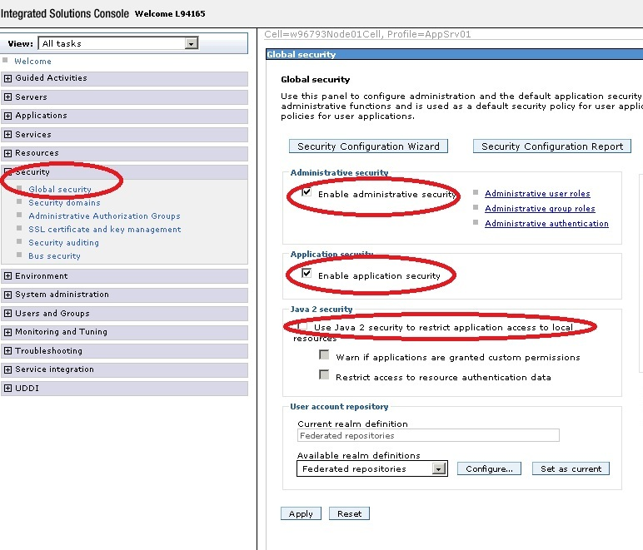

1. Apply and save to master.
2. Then configure the LDAP by selecting **Standalone LDAP registry** and click **configure**:

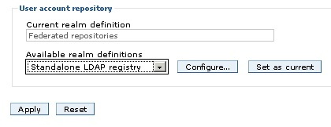

1. Now fill in the LDAP information.
   * **Primary administrative User Name** is the user that you will use for administrating WAS
   * **Type** should be "custom".
   * **Host** is the fully qualified name of the AD server.
   * **Port** is, if you are not using SSL, standard 389. If SSL is used, see this [techtip](https://jazz.net/library/techtip/96) for extra steps involved.
   * **Base distinguished name DN** can be found with [Softterra LDAP Browser](http://www.softerra.com/download.htm):
     + Create a new profile with the logon you have and the ldap server.
     + To find a user, use the filter objectClass=person. The results might vary and if no results are found you can either browse for a user or ask the AD admin what object class people/users/persons are stored in.

Sample screen capture

* + - Open up one of the found users and look at the values. The field name might be distinguished name (dn) or something like that. The DC values should look like your company's email address, and a group should be listed after OU.

Sample screen capture

* + **Bind password** and **user** is the user that you use for doing lookups in the AD. It is the same as the one you logged into the LDAP browser with.

1. Finally, test the connection to see that you can actually connect to the AD (this does not mean that everything works just yet).

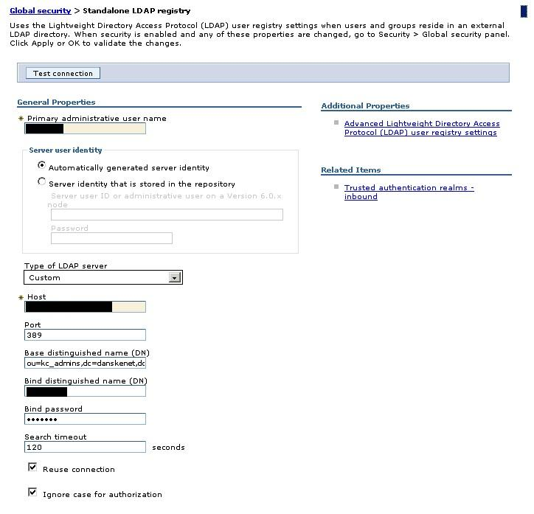

1. Click **Ok** and save to master configuration

Configure the advanced LDAP settings

1. Now click **Advanced LDAP User Registry Settings**:

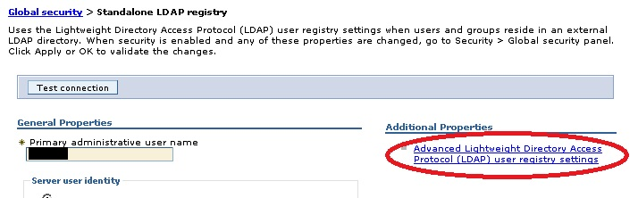

1. Fill in the property fields:
   * **User filter** should contain the field name that contains the unique and short id of a user. Look for a field with this value in the LDAP browser:

Sample screen capture

* + **objectClass** is the class name of the type of class that contains users. It is the same value as what you browsed for when finding users earlier.
  + **Group filter** should contain the field on an object type that contains the group (in the sample the object class is "group"). Look for a value that contains the short group name.

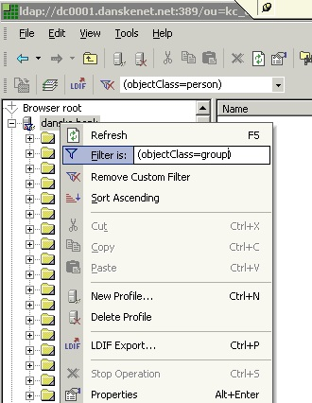

Sample screen capture

Sample screen capture

* + **User ID map** and **Group ID map** should be set to the same 2 fields with the unique identifier, unless another kind of mapping is desired.
  + Finally **Group member ID map** should be set to the value on a user that contains its membership to the various groups and this should be mapped to value member(for microsoft AD):

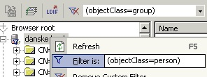

Sample screen capture

* + - In this sample the fieldname is "memberOf"
  + More info on these fields can be found at: [Configuring Lightweight Directory Access Protocol user registries](http://publib.boulder.ibm.com/infocenter/wasinfo/v6r1/index.jsp?topic=/com.ibm.websphere.base.doc/info/aes/ae/tsec_ldap.html)
  + **When filled out our sample looks like this:**

1. Click **ok** and save to master configuration

**Verify your general settings**

1. From the global settings under security go to websecurity and general settings and verify these settings:

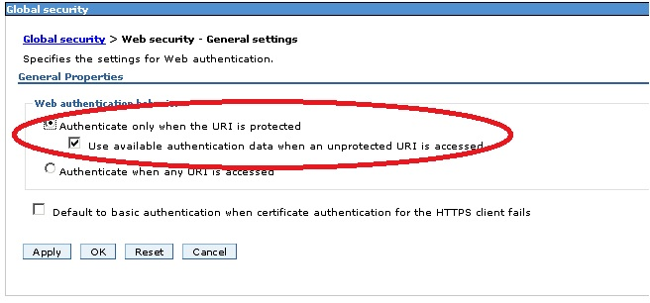

1. Save to master if necessary (eg. if any changes were made).

**Verify your advanced settings**

1. From the Global Security page select the **LDAP standalone** and click **set as current**. When saved, the configuration will be tested.
2. If all proves ok, you can now set up your user to be a WAS administrator user. To do this click on **administrative user roles**:

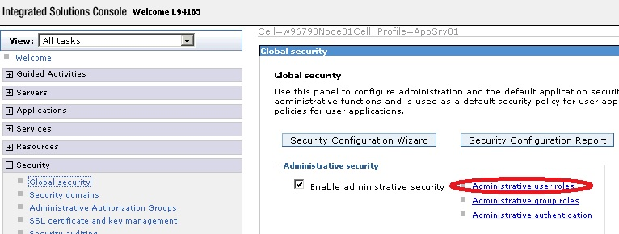

1. If you cannot find any users, the advanced setup is most likely wrong.
2. After this, you can verify that your advanced settings on the groups are correct by adding the JazzAdmins as administrators for WAS also.

**Map your groups**

1. After this, the application must have the 5 groups mapped to the jazz groups:
2. Open **Applications > Websphere Enterprise Applications** and click **jazz.war**

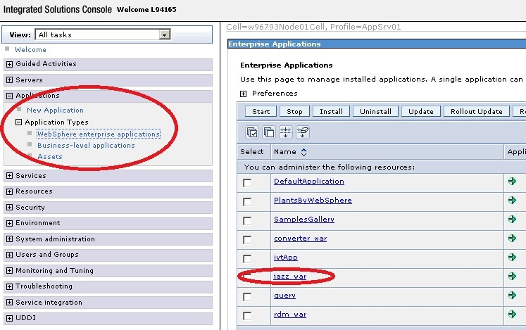

1. Click **security role to user/group mapping**

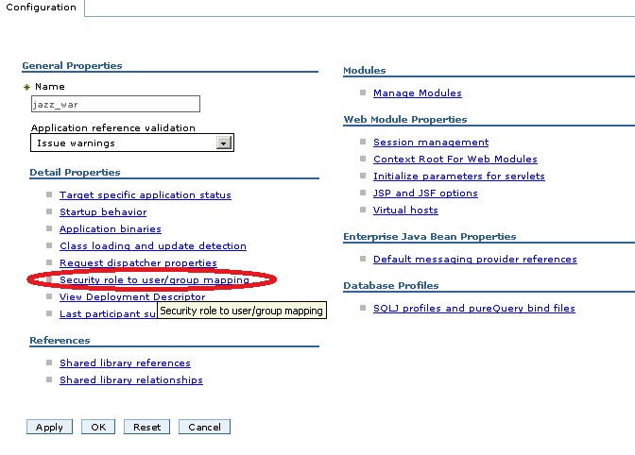

1. Map your groups:

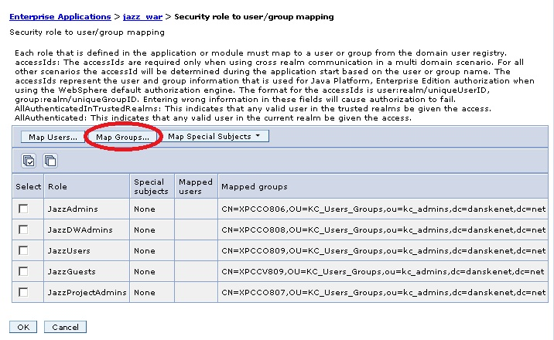

1. Save the configuration.
2. Now, after restarting WAS, you should be able to log in with your AD user on both WAS and RRC/RTC/RQM. If you can log into jazz, but get the message that the user is not allowed to view the admin UI, something is most likely wrong with your advanced settings in Group member ID mapping.
3. You can override this by mapping your private user to the admin group in the same window, as was done just above. This, however, will not be useful in the long run.

Configuring the Jazz server:

1. To enable the the LDAP synchronization, log in to the Jazz server and from the admin UI and click **advanced properties**:
   * **Base Group DN** can be found by looking at a group in the LDAP browser. Look for a value like the company email address:

Sample screen capture

* + - This line in the LDAP browser tells us that the value should be ou=KC_Users_Groups,ou=kc_admins,dc=danskenet,dc=net
  + **Base User DN** is the same as we found earlier for WAS.
  + The value for **Find Groups for User** is set to "member" for this AD like it was in the WAS group mapping.
  + **Find Groups by Any Name Query** should be set to a field containing the name of a user.
  + **Find Users by User Id Query** should be set to the same field as in WAS for locating the unique user Id.
  + **Group Member Property** should be set to that property value that holds the member value. This is the same as what is found in the mapping when setting up the WAS.
  + **Group Name Property** should be set to the field in the objectClass for groups that contains the groups name.
  + **Jazz to LDAP mapping** should list the 5 jazz groups mapped to your AD groups like JazzAdmins=MyADJazzAdminsGroup.
  + **Ldap Registry Location** is the full server and port of the AD.
  + **Password** and **User** is set to the values of the Bind user (the user used for making lookups in AD). If the AD allows anonymous login, these should be left blank.

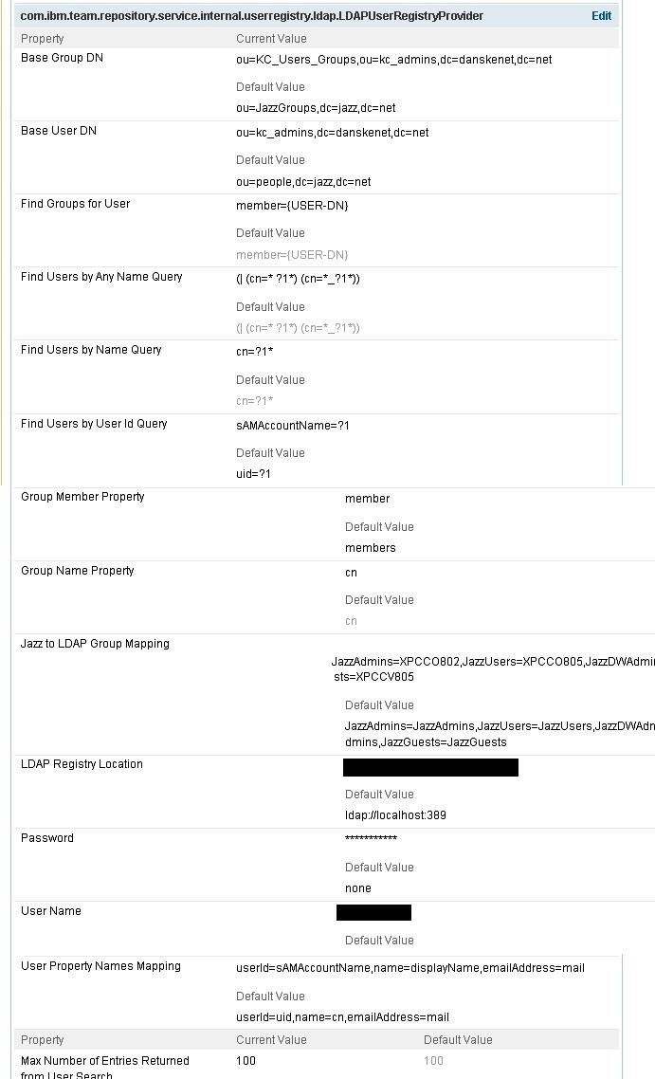

1. Preview and save your settings
2. Now enable the syncronization:

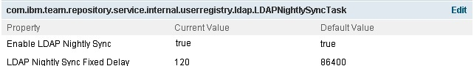

1. Notice I have changed the delay to 2 minutes (120 sec) to avoid waiting a full day for testing.
2. Preview and Save
3. Finally, set the authentication method to LDAP:

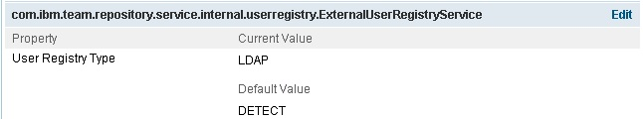

1. Preview and Save.
2. Restart the Jazz application or the entire websphere server. Now you are finished setting up LDAP for Jazz applications on WAS.

**Tips**

* If users already exist before enabling LDAP, you can ensure that they are only updated and not duplicated if their userid matches that of the AD.
* Set the Default License ID to some license so all new users automatically get a license:

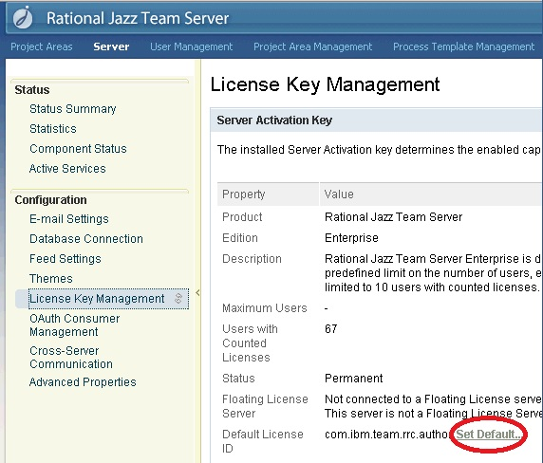

* You can monitor which users are updated using the link: https://myjazzserver:9443/jazz/events?provider=ldapnightlysync#
* You can trace LDAP problems by changing the log4j.properties file (output can be found in jazz.log):

################################

# LDAP access from jazz #

################################

# Turn on INFO messages from LDAP nightly sync task

#log4j.logger.com.ibm.team.repository.service.internal.userregistry.ldap=INFO

#Turn on query trace against the LDAP server

log4j.logger.com.ibm.team.repository.service.internal.userregistry.ldap.LDAPUserRegistry=DEBUG

* You can trace also using this tool: [Validate LDAP tool](https://jazz.net/library/content/articles/rtc/2.0.0.2/jazz-ldap-on-was/ValidateLDAP.zip)
* The LDAP values in jazz can be manually changed without logging in by editing teamserver.properties and restarting the app or the entire server.

## Configuration of CLM with WAS ND & IBM HTTP Server.

The following components will have deployed on the following hosts in the deployment that will be built.

**DB2 Database:** clmdb.jazz.net  
**Deployment Manager:** clmdm.jazz.net  
**Nodes:** clmapps.jazz.net, clmjts.jazz.net  
**Proxies:** clmproxy.jazz.net

All application contexts will be accessible under the following:

**Jazz Public URI:** clm.jazz.net

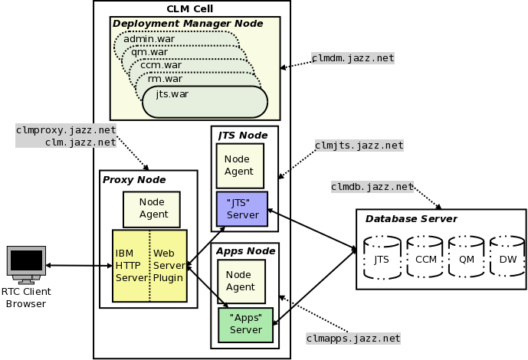

Important Prerequisites

The first task is to create a distributed WebSphere Application Server - Network Deployment Edition (WAS ND) topology.  To do this you will need to set up the following hosts:

**clmproxy.jazz.net:**

* IBM [WebSphere](https://jazz.net/wiki/bin/view/Main/WebSphere) Application Server Network Deployment V8.0.0.4
* IBM HTTP Server V8.0.0.4, 64 bit
* IBM WebSphere Web Server Plugin V8.0.0.4

**clmdm.jazz.net:**

* IBM [WebSphere](https://jazz.net/wiki/bin/view/Main/WebSphere) Application Server Network Deployment V8.0.0.4

**clmjts.jazz.net:**

* IBM [WebSphere](https://jazz.net/wiki/bin/view/Main/WebSphere) Application Server Network Deployment V8.0.0.4
* IBM Rational CLM 4.0 (JTS & RM applications only)

**clmapps.jazz.net:**

* IBM [WebSphere](https://jazz.net/wiki/bin/view/Main/WebSphere) Application Server Network Deployment V8.0.0.4
* IBM Rational CLM 4.0 (CCM & QM applications only)

This article assumes:

* All of the nodes should recognize each other by their host names
* All hosts are configured so that they are using an Network Time Protocol (NTP) server. This is to prevent clock discrepancies.
* The RDBMS (Oracle, DB2 or SQLServer) are already installed and databases are created
* An LDAP Server has been set up that is to be used for authentication.
* WebSphere Application Server V8.0.0.3 (or later) is installed on clmproxy.jazz.net, clmdm.jazz.net, clmapps.jazz.net and clmjts.jazz.net with no profiles created. (Do not launch the profile management tool at the end of the WebSphere Installation)
* IBM HTTP Server V8.0.0.3 (or later), Web Server Plug-ins for WebSphere Application Server V8.0.0.3 (or later) installed on clmproxy.jazz.net
* CLM 4.0, CCM and QM is installed on clmapps.jazz.net and CLM 4.0, JTS and RM on clmjts.jazz.net but **not** set up yet.

Most instructions provided using Unix-style syntax though the instructions will work as well on Windows if equivalents are used.

**Create the Deployment Manager**

On the host on which the deployment Manager resides (clmdm.jazz.net).  Launch the Profile Management Tool, it can be launched from:

<WAS ND Installation Directory>/bin/ProfileManagement/pmt.(sh|bat)

Once the Profile Management Tool has launched, click the **"Create..."** button. In the dialog window that opens:

1. Select **"WebSphere Application Server -> Management"**, click **"Next >"**
2. Select **"Deployment manager"**, click **"Next >"**
3. Select **"Advanced profile creation"**, click **"Next >"**
4. Leave the defaults, click **"Next >"**
5. Leave the defaults, click **"Next >"**
6. Ensure that the values correspond to your environment. For example:  
   **Node name:** clmCellManager01  
   **Host name:** clmdm.jazz.net  
   **Cell name:** clmCell01  
   Click **"Next >"**
7. Keep "Enable administrative security" enabled and choose an administrative **user name** and **password**. For Example:  
   **User name:** admin  
   **Password:** admin  
   Click **"Next >"**
8. Leave the defaults, click **"Next >"**
9. Leave the defaults, click **"Next >"**
10. Leave the default ports, click **"Next >"**
11. Choose whether to run dmgr as a service, click **"Next >"**
12. click **"Create"**

Ensure that the deployment manager is started.

<WAS ND Installation Directory>/bin/startManager.[sh|bat]

**Enabling Automatic Node Synchronization**

As there will be a lot of configuration changes, automatic synchronization of configuration changes with the node should be enabled to prevent having to constantly manually do so.

1. Open a browser and navigate to the deployment manager's Integrated Solutions Console at [https://clmdm.jazz.net:9043/ibm/console](http://clmdm.jazz.net:9043/ibm/console)
2. **"System Administration->Console Preferences"** and select **"Synchronize changes with Nodes"**
3. Click **"Apply"**

**Setting up Global Security**

It is recommended to fully configure the deployment manager security before creating the nodes which will host the application servers. It is preferable to do this before adding nodes, as the nodes use authentication to communicate with the deployment manager and deploying the nodes then changing the security after, will require the resynchronization of the nodes manually. This can be avoided by setting up global security first.

For this example, the file-based user repository built into WAS ND will be used to manage Jazz users and groups as in [article 97](https://jazz.net/library/article/97). If an LDAP server is used, then the guidance in [article 96](https://jazz.net/library/article/96) , [article 549](https://jazz.net/library/article/549) and [article 479](https://jazz.net/library/article/479) should be followed. It is important to do this before adding nodes as the nodes use authentication to communicate with the deployment manager and deploying the nodes then change authenticate after, you will need to re-sync the nodes manually. This can be avoided by setting up authentication first.

**Create the application server and proxy node agents**

The steps in this section should be repeated for each application server node (clmjts.jazz.net & clmapps.jazz.net) and for the proxy node (clmproxy.jazz.net).

On the node host,  launch the Profile Management Tool. It can be launched from:

<WAS ND Installation Directory>/bin/ProfileManagement/pmt.[sh|bat]

Once the Profile Management Tool has launched, click the **"Create..."** button. In the dialog window that opens:

1. Select **"WebSphere Application Server -> Custom Profile"**, click **"Next >"**
2. Select **"Advanced profile creation"**, click **"Next >"**
3. Use a profile name and path that is representative of the node's purpose. Example:  
   **Profile name:**JTS  
   **Profile directory:** /opt/IBM/WebSphere/AppServer/profiles/JTS  
   Click **"Next >"**
4. Also ensure that the node name is representative of the nodes purpose and ensure that the host name is correct. For example:  
   **Node name**: jtsNode  
   **Host name:** clmjts.jazz.net  
   Click **"Next >"**
5. Enter the values that correspond to the location, administrative user name and password of the deployment manager. For Example:  
   **Deployment manager host name or IP address:** clmdm.jazz.net  
   **Deployment manager SOAP port number (Default 8879):** 8879  
   **User name:** admin  
   **Password:** admin  
   Click **"Next >"**
6. Leave the defaults, click **"Next >"**
7. Leave the defaults if appropriator or change the distinguished names to be representative of the node. For Example:  
   **Issued to distinguished name:** cn=clmjts.jazz.net,ou=jtsNodeCell,ou=jtsNode,o=IBM,c=US  
   **Issued by distinguished name:** cn=clmjts.jazz.net,ou=Root Certificate,ou=jtsNodeCell,ou=jtsNode,o=IBM,c=US  
   Click **"Next >"**
8. Leave the default ports, click **"Next >"**
9. Click **"Create"**

Ensure that the node agent is started:

<WAS ND Installation Directory>/bin/startNode.[sh|bat]

Remember that you must repeat these instructions for the each node, For this article we will use the following profiles:

|  |  |  |
| --- | --- | --- |
| **clmCell01** | | |
| **Host** | **Profile Name** | **Node Name** |
| clmproxy.jazz.net | Proxy | clmProxy |
| clmdm.jazz.net | Dmgr01 | clmCellManager01 |
| clmjts.jazz.net | JTS | clmJTS |
| clmapps.jazz.net | Apps | clmApps |

**Creating the Web Server Definition**

This section covers the process of creating a web server. A web server is a configuration entry in deployment  manager that represents and IBM HTTP Server and associated WebSphere Web Server Plug-in. We create a server when we want to use IBM HTTP Server as a proxy.

1. Open a browser and navigate to the deployment manager's Integrated Solutions Console at [https://clmdm.jazz.net:9043/ibm/console](http://clmdm.jazz.net:9043/ibm/console)
2. Navigate to **"Servers -> Server Types-> Web servers"** and click the **"New..."**Button
3. On the next page, select the proxy node (clmproxy.jazz.net) that was created previously (and into which IBM HTTP Server and the IBM Web Server Plug-ins were installed). For example, enter the following values:  
   **Select node:**proxyNode  
   **Server name:** IHS  
   **Type:** IBM HTTP Server  
   Click **"Next"**
4. Click **"Next"**
5. Ensure the installation directories for the IBM HTTP Server and Plug-ins are correct. Note that these are the installation directories on the node itself and it may very well be the case that the "Plug-in installation location" is /opt/IBM/WebSphere/Plugins rather than /opt/IBM/HTTPServer/Plugins. Make sure to specify the correct directory where the plug-ins were installed. For Example, specify the following values:  
   **Port:** 80  
   **Web server installation location:** /opt/IBM/HTTPServer  
   **Plug-in installation location:** /opt/IBM/WebSphere/Plugins  
   **Application mapping to the Web server:** All  
   Click **"Next"**
6. Click **"Finish"**
7. Click **"Save"** to **"Save directly to the master configuration"** when prompted

The Web Server should now be listed. There is a post web-server creation step that may be needed. Sometimes, this entry is automatically added to httpd.conf but sometimes it is not.

1. Click on the newly created web server **"IHS"** link
2. Click on the **"Configuration File"** link in the **"Additional Properties"** Section
3. If not already in the file, add the following two likes at the end of it:
4. LoadModule was_ap22_module <WebSphere Web Server Plug-ins Install Location>/bin/64bits/mod_was_ap22_http.[so|dll]

WebSpherePluginConfig <WebSphere Web Server Plug-ins Install Location>/config/IHS/plugin-cfg.xml

**Note**: mod_was_ap22_http may be in the 32bits folder and not in the 64bits folder depending on the proxy architecture.

1. Click **"OK"**
2. Click **"OK"**
3. Click **"Save"** to **"Save directly to the master configuration"** when prompted

**Creating the Secure Virtual Host**

All the CLM applications listen on a secure port by default, so it would be a good idea that the proxy respects this configuration and is itself using SSL. In any case, it will need to communicate with the back end servers using SSL so those certificates will be needed. In a production system one would typically obtain a certificate from a certificate authority. In this scenario, a self-signed certificate is used.

1. Open a browser and navigate to the deployment manager's Integrated Solutions Console at [https://clmdm.jazz.net:9043/ibm/console](http://clmdm.jazz.net:9043/ibm/console)
2. Navigate to **"Servers -> Server Types-> Web servers"** and click the **"IHS"** server
3. On the next page, select the **"Web Server Virtual Hosts"** in the **"Configuration settings"**
4. Click **"New..."**
5. On the page that appears next, select **"Security enabled virtual host"** as an SSL host will be set up. Click **"Next"**
6. A self signed certificate will now be created. Enter the following, for example:  
   **Key store file name:** IHS  
   **Target key store directory:**$(WEB_INSTALL_ROOT)/conf  
   **Key store password:**WebAS  
   **Verify key store password:** WebAS  
     WebSpheregenerally uses "WebAS" as a default for key stores and this is used in this example to keep things consistent. Click **"Next"**
7. Enter the following value:  
   **IP Address:** 0.0.0.0  
   **Port:** 443  
   Click **"Next"**
8. Click **"Finish"**
9. Click **"Save"** to **"Save directly to the master configuration"** when prompted

**Creating a "JTS" Application Server (for "JTS" and "RM")**

We will create one application server that will be used as a template to create additional application-agnostic CLM application servers. It is assumed that the JTS and RM CLM 4.0 application are installed on the node where the JTS application server will be created.

1. Open a browser and navigate to the deployment manager's Integrated Solutions Console at [https://clmdm.jazz.net:9043/ibm/console](http://clmdm.jazz.net:9043/ibm/console)
2. Navigate to the **"Server->Server Types->WebSphere Application Servers"** Topic and click **"New..."**
3. On the next page, select an application server node (clmjtsjazz.net) that was created previously. For example, enter the following values:  
   **Select node:**jtsNode  
   **Server name:** JTS  
   Click **"Next"**
4. Select the **"default"** template. Click **"Next"**
5. On the next page **"Generate Unique Ports"** can be deselected if this is the only application server on the node.  
   **Generate Unique Ports:** false  
   Click **"Next"**
6. Click **"Finish"**
7. Click **"Save"** to **"Save directly to the master configuration"** when prompted

**Checking virtual hosts**

In order to make sure that the application server is listening on the ports for the host on which it is in installed, their needs to be a virtual host entry for the ports. As "Generate Unique Ports" in step 4 above, the default listening ports are 9080 for http and 9443 for https. If this option was not chosen, then the port numbers for the application server can be found as follows:

1. Navigate to **"Servers->Server Types->WebSphere Application Servers"** and click on the server name **"JTS"**
2. On the right side under **"Communications->Ports"**, **"WC_defaulthost"** and **"WC_defaulthost_secure"** can be found along with the corresponding port numbers.

Take note of these ports and ensure that these ports are also in a virtual hosts entry for the host on which the application server is installed on (clmjts.jazz.net). This is important because when applications are installed they are bound to a virtual host, a set of host->port number combinations that determines what hosts and ports the application will be listening on. When an application module is targeted to a server, WAS ND only allows the application to listen on a host->port combination that is in the virtual hosts list. We know that we want applications to listen on the secure port, maybe also the unsecured ports for this server so we need to that the host clmjts.jazz.net and port 9080 and 9443 are in that list.

1. Navigate to **"Environment->Virtual Hosts"** and there should be a mappings called **"default_host".** Click on **"default_host"**
2. Click on **"Host Aliases"** in the **"Additional Properties"**section
3. The list of host->port mappings for the hosts should be now show. Any application that is tied to **"default_host"** can listen on these combinations, assuming there is a application server listening on them. There may already be a list for each node host along with a wild card entry. It make things easier to have all nodes with application servers listening on the same ports (Unselected **"Generate Unique Ports"** when creating an application server ensures this). If this was not the case, different host entries are needed to identify the unique ports that the server is listening on.

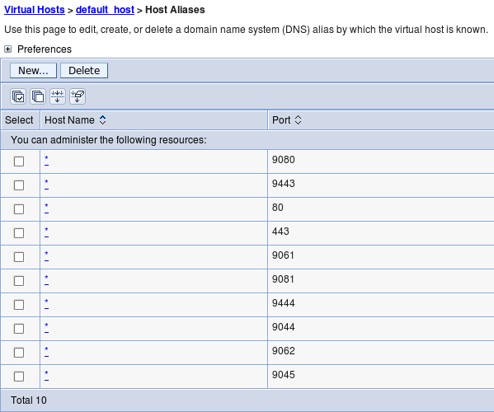

**Preparing the Application Server for CLM**

As mentioned previously, this application server **"JTS"** will be used as a template for the a new **"Apps"** server. CLM 4.0 should already be installed in a location on both the clmJTS (clmjts.jazz.net) and clmApps (clmApps) nodes.

Follow the [instructions in the information center for WAS](https://jazz.net/help-dev/clm/topic/com.ibm.jazz.install.doc/topics/t_s_server_installation_setup_WAS.html) taking the note of the following differences:

* Global security should be setup by now, so the steps related top security shouldn't need to be followed. If some of the options mentioned in the information center were not applied, then they should be applied but the deployment manager will need to be restarted and the nodes resynchronized. To resynchronize the nodes they must be stopped and the [syncNode](http://pic.dhe.ibm.com/infocenter/wasinfo/v8r0/topic/com.ibm.websphere.nd.multiplatform.doc/info/ae/ae/rxml_syncnode.html) command executed and then restarted.
* References to **"Servers > Server Types > WebSphere application servers > Server1"**should instead be **"Servers > Server Types >WebSphere application servers > JTS"**

In addition to these standard setup instructions, the application servers needs to additional customer properties:

1. Navigate to**Servers -> Server Types -> WebSphere application servers"** Click **"JTS"**
2. Under "**Container Settings**" expand **"Web Container Settings"**. Click "**Web Container**".
3. Add the following custom properties:
4. trusthostheaderport = true

com.ibm.ws.webcontainer.extracthostheaderport = true

1. Click **"Save"** to **"Save directly to the master configuration"** when prompted

**Creating "CLM 4.0" Application Server Template**

Templating the **"JTS"** application server will allow us to keep all the settings that have been set.

1. Go to **"Servers->Server Types->WebSphere application servers"**, select the server and click the **"Templates..."** button
2. Click **"New..."**, Select the **"JTS"** server.  Click **"OK"**

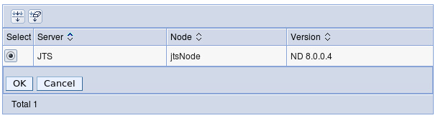

1. Enter  
   **Name:** CLM 4.0  
   **Description:** Template for CLM 4.0 application servers  
   Click **"OK"**
2. Click **"Save"** to **"Save directly to the master configuration"** when prompted

Now it is possible to use this template to create the "Apps" application server.

**Creating an "Apps" Application Server (for QM & CCM)**

It is assumed that the CLM 4.0 (QM and CCM) is installed on the node where the JTS application server will be created.

1. Navigate to the **"Server->Server Types->WebSphere Application Servers"** Topic and click **"New..."**
2. On the next page, select an application server node (clmjtsjazz.net) that was created previously. For example, enter the following values:  
   **Select node:**appsNode  
   **Server name:** Apps  
   Click **"Next"**
3. Select the **"CLM 4.0"** template. Click **"Next"  
   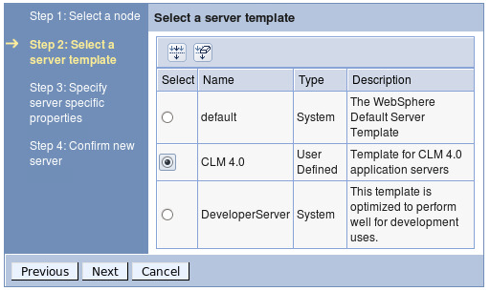**
4. On the next page **"Generate Unique Ports"** can be deselected if this is the only application server on the node.  
   **Generate Unique Ports:** false  
   Click **"Next"**
5. Click **"Finish"**
6. Click **"Save"** to **"Save directly to the master configuration"** when prompted

As previously with the **"JTS"** server, ensure the virtual hosts set up is correct.

**Deploying the CLM applications**

The instructions in the [CLM 4.0 information center regarding application deployment](https://jazz.net/help-dev/clm/topic/com.ibm.jazz.install.doc/topics/t_deploy_was.html) with the following exceptions and additions:

* Ignore the instructions at the beginning to restart the application server. We have not yet started the servers we created anyway.
* Either:
  + Use a browser located on the jtsNode node (clmjts.jazz.net) to install the jts,rm and converter war files and then use a browser located on the appsNode node (clmapps.jazz.net) to install the ccm and qm war files to install the war files  
    OR
  + Copy the jts.war,rm.war and converter.war from jtsNode (clmjts.jazz.net) and ccm.war and qm.war from appsNode (clmapps.jazz.net)  to a computer with a browser and access the deployment manager's Integrated Solutions Console from there to install the war files.
* Step 9 has additional sub-steps:
  1. In the **"Modules"** section, click **"Manage Modules"**
  2. Ensure the**jts.war**modules is targeted to both the **"IHS"**web server and the **"JTS"** application server. If it is not, select the **"jts.war"** entry, select both the **"JTS"**application server and**"IHS"**entries in the**"Clusters and servers"** box and click **"Apply"**

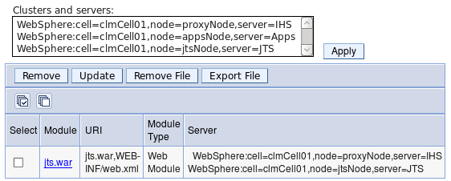

* 1. Click **"OK"**
  2. Click **"Save"** to **"Save directly to the master configuration"** when prompted
* Target the **"Admin","JTS"** and **"RM"** modules to the **"IHS"** and **"JTS"** servers, and target the **"CCM"** and **"QM"** modules to the **"IHS"** and**"Apps"** servers.
* The clmhelp.war file can be installed on any server of choice.

**Updating the Web Server Plug-in configuration**

Once all the war files have been installed the the environment, the web server proxy plug in configuration needs to be updated with the new application mappings applied.

1. Open a browser and navigate to the deployment manager's Integrated Solutions Console at [https://clmdm.jazz.net:9043/ibm/console](http://clmdm.jazz.net:9043/ibm/console)
2. Navigate to **"Environment -> Update global Web server plug-in configuration"**
3. Click **"Overwrite"**
4. Navigate to **"Servers -> Server Types-> Web servers"**
5. Select the **"IHS"** Web Server
6. Click the **"Generate Plug-in"** button
7. Click the **"Propagate Plug-in"** button

**Starting and setting up CLM**

At this point, all the war files should be installed and the web server proxy should be updated. All that remains is to start all the servers and run CLM setup from the public URI (which should be pointing to the proxy server, clmproxy.jazz.net). In this article, we use the example public URI: http://clm.jazz.net/<app>. But first, the server need to be started:

1. Open a browser and navigate to the deployment manager's Integrated Solutions Console at [https://clmdm.jazz.net:9043/ibm/console](http://clmdm.jazz.net:9043/ibm/console)
2. Navigate to **"Servers -> Server Types-> Web servers"**
3. Select the **"IHS"** Web Server
4. Click the **"Start"** button  
   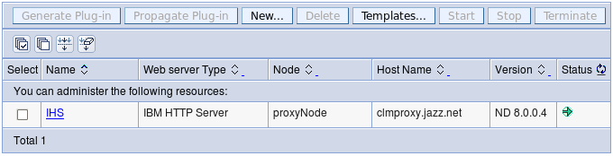

After some time, a green arrow pointing right should appear in the**"Status"**column. Now lets start the application servers:

1. Navigate to the **"Server->Server Types->WebSphere Application Servers"**
2. Select both the **"JTS"** and **"Apps"** servers
3. Click the **"Start"** button  
   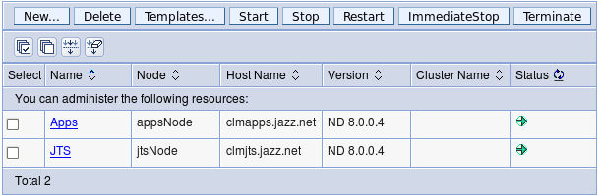

After some time, a green arrow pointing right should appear in the**"Status"**column. Everything is no ready to run the JTS setup and setup the CLM application.

1. Open a browser and navigate to Public URI at [https://clm.jazz.net/jts/setup](http://clmdm.jazz.net:9043/ibm/console)
2. Follow the instructions in the [CLM 4.0 Information Center on how to run the CLM setup](https://jazz.net/help-dev/clm/topic/com.ibm.jazz.install.doc/topics/t_s_server_installation_setup_wizard.html) noting the following:
   1. The public URI is **"https://clm.jazz.net/jts"** so https://clm.jazz.net/jts/setup should be used to run setup instead of the URL identified in the instructions.
   2. Step 7c should be followed as CCM and QM are installed on another server.
      * **/rm** and**/admin** should be detected automatically as they are on the same server as**/jts**
      * **/ccm** and **/qm** need to be added manually with the Discovery URL's **"https://clm.jazz.net/ccm/scr**" and**"https://clm.jazz.net/qm/scr"** respectively.  
        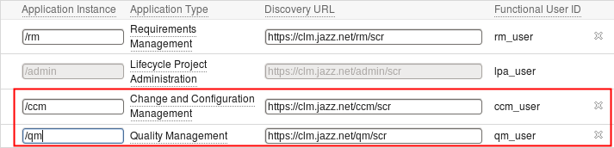
   3. After**/ccm** and **/qm** have been added manually, then click **"Register Applications"**

That's it! All done! The applications can be accessed using

* **JTS: http://clm.jazz.net/jts**
* **RM: http://clm.jazz.net/rm**
* **CCM: http://clm.jazz.net/ccm**
* **QM: http://clm.jazz.net/qm**
* **LPA: http://clm.jazz.net/admin**

# Installation of Rational DOORS

* Installation of Rational DOORS Server
* Installation of DWA
* Configuration of DOORS with RTC, RQM

## Install Rational DOORS.

There are several components required to install Rational DOORS with DOORS Web Access:

* Rational DOORS client
* Rational DOORS database server
* Rational DOORS Web Access server - An adaptation of Apache Tomcat. Tomcat is an application server that executes Java™ servlets and renders web pages that include JavaServer Pages (JSP) code.
* Rational DOORS Web Access broker - An adaptation of Apache ActiveMQ. ActiveMQ is an open source message broker that implements the Java Message Service (JMS).
* Interoperation server - A Rational DOORS client that you run from the command line.

***New installation of Rational DOORS on Windows***

This chapter describes how to install and set up Rational DOORS 9.2 on a machine that does not have a previous version of Rational DOORS installed. If you want to upgrade your current version of Rational DOORS, follow the instructions in either “Upgrading from version 9.0 and later

This chapter contains the following:

•Installing the Rational DOORS database server

•Installing the Rational DOORS client

•Installing Rational DOORS for Rational Quality Manager Interface

•RDS, the Rational DOORS database and UUIDs

•Installing the Rational DOORS Example Data

•Uninstalling Rational DOORS

**Installing the Rational DOORS database server**

Follow these steps to install the Rational DOORS database server.

**Note** If you are installing both the Rational DOORS client and the Rational DOORS database server on the same machine, install the Rational DOORS client first. The Rational DOORS database server and the Rational DOORS client share components. If you install the server before the client, you might need to restart your machine during the client installation. For information about the client installation, see “Installing the Rational DOORS client,” on page 12. When you have installed the Rational DOORS client, follow the steps to install the Rational DOORS database server.

**1.**Check that you meet the system requirements. Details of system requirements are on our Web site at http://www-01.ibm.com/software/awdtools/doors/sysreqs/.*New installation of Rational DOORS on Windows 10 Rational DOORS Installation Guide*

**2.**Make sure the IBM® Rational® License Server TL is installed on your system. For information about installing the Rational License Server TL, see the *Rational License Server TL Licensing Guide*, which is available from the **Rational Lifecycle Solutions DVD**, and from our Web site at http://publib.boulder.ibm.com/infocenter/rsdp/v1r0m0/index.jsp.

**3.**Make sure that you are logged on to your computer as the local Administrator, and not a user with Administrator privileges.

**4.**Shut down all other applications. In particular, shut down Microsoft® Office applications, including the Microsoft Office toolbar.

**5.**You can either install from the Rational Solutions DVD or from Rational DOORS software downloaded from the Rational Web site.

If you are installing from DVD, put the **Rational Lifecycle Solutions DVD** into your DVD-ROM drive, browse to the Rational DOORS server software and click to install. The Rational DOORS database server installer runs, and the **Welcome** screen is displayed.

If you downloaded the Rational DOORS database server software from the Web site, navigate to the file you downloaded, and double-click it. The Rational DOORS database server installer runs, and the **Welcome** screen is displayed.

**6.**Click **Next**.

The **License Agreement** screen is displayed.

**7.**If you accept the terms of the license agreement, select the **I accept...** option and click **Next**.

If you do not have a Rational DOORS client installed on your machine, the **Destination Folder** screen is displayed. If you have a Rational DOORS client installed, the **Setup Type** screen is displayed. Go to step 9.

**8.**Enter the path to the folder you want to use for your Rational DOORS installation, or leave the default.

If you want to change the directory:

**a.**Click the **Change** button.

**b.**Browse to the directory you want to install to.

**c.**Click **OK**.

The **Setup Type** screen is displayed.

**9.**Select either the **Custom** setup type or the **Typical** setup type, and click **Next**.*Rational DOORS Installation Guide 11 Installing the Rational DOORS database server*

The **Custom** setup type installs the Rational DOORS database server and the Rational DOORS server interface services. These allow Rational DOORS to interface with selected other products, for example Rational Requirements Composer. For information about using the **Custom** setup type to install, see “Installing the Rational DOORS server interface services on Windows,” on page 41.

**Note** This method of integrating with other products is not used for integrations like Rational DOORS for ClearCase Interface, Rational DOORS for ClearQuest Interface, and so on. For information about installing these integrations, see the appropriate chapter in this guide.

The **Typical** setup type installs the Rational DOORS database server.

The **DOORS Database Server Settings** screen is displayed.

**10.**Enter the Port Number and the Data Directory.

**a.**In **Port Number**, type the port number to be used by your Rational DOORS database server. Do not use a number lower than 1000. The default port used by Rational DOORS is 36677.

**b.**In **Data Directory**, type the path to the directory you want to use for your Rational DOORS database. This directory must be on the local machine and is where your data and user information are stored. Rational DOORS does not support mapped drives for data.

**c.**Click **Next**.

**Note** If the port you specified is already being used by another application, a message is displayed. Click **OK**, type a different port number and click **Next.**

The **Ready to Install the Program** screen is displayed.

The settings you defined in the previous steps are displayed. Use the **Back** button if you want to change any of your settings.

**11.**Click **Install**.

**12.**When all the files are installed, the **Finish** screen is displayed. Click **Finish** to complete the installation.*New installation of Rational DOORS on Windows 12 Rational DOORS Installation Guide*

**Installing the Rational DOORS client**

If you are installing both the Rational DOORS client and the Rational DOORS database server on the same machine, install the Rational DOORS client first.

**1.**Ensure that you have a Rational DOORS 9.2 license. For more information about licensing, see the *Rational License Server TL Licensing Guide*, which is available from the **Rational Lifecycle Solutions DVD**, and from our Web site at http://publib.boulder.ibm.com/infocenter/rsdp/v1r0m0/index.jsp.

**2.**Check that you meet the system requirements. Details of system requirements are on our Web site at http://www-01.ibm.com/software/awdtools/doors/sysreqs/.

**3.**Make sure the Rational License Server TL is installed on your system. For information about installing the Rational License Server TL, see the *Rational License Server TL Licensing Guide*.

**4.**Make sure that you are logged on to your computer as the local Administrator, and not a user with Administrator privileges.

If you cannot log in to your computer as the local Administrator, see “Installing Rational DOORS as a non-admin user,” on page 95.

**5.**Shut down all other applications. In particular, shut down Microsoft Office applications, including the Microsoft Office toolbar.

**6.**You can either install from the Rational Solutions DVD or from Rational DOORS software downloaded from the Rational Web site.

If you are installing from DVD:

**a.**Put the **Rational Lifecycle Solutions DVD** into your DVD-ROM drive, browse to **Rational Lifecycle Solutions Clients**, and click to install.

The **Rational Lifecycle Solutions Setup** runs, and the **Welcome** screen is displayed.

**b.**Click **Next**.

The **License Agreement** screen is displayed.

**c.**If you accept the terms of the license agreement, select the **I accept...** option and click **Next**.

The **Select Products** screen is displayed.

**d.**If you only want to install Rational DOORS, clear all the other options and click **Next**. Go to step 9.*Rational DOORS Installation Guide 13 Installing the Rational DOORS client*

For information about installing products other than Rational DOORS, see the appropriate installation manual, which is available from the **Rational Lifecycle Solutions DVD**.

If you downloaded the Rational DOORS client software from the Web site, navigate to the file you downloaded, and double-click it.

The **Welcome** screen is displayed.

**7.**Click **Next**.

The **License Agreement** screen is displayed.

**8.**If you accept the terms of the license agreement, select the **I accept...** option and click **Next**.

**9.**The **Destination Folder** screen is displayed.

Enter the path to the folder you want to use for your Rational DOORS installation, or leave the default.

The default installation folder is C:\Program Files\IBM\Rational\DOORS\9.2.

If you want to change the directory:

**a.**Click the **Change** button.

**b.**Browse to the directory you want to install to.

**c.**Click **OK**.

**10.**Click **Next**.

The **Setup Type** screen is displayed.

**11.**Select either the **Custom** setup type or the **Typical** setup type.

The **Custom** setup type installs the Rational DOORS client, the Rational DOORS for Rational Quality Manager Interface client, and the Rational DOORS for Rational Quality Manager Interface server. For information about using the **Custom** setup type, see “Installing Rational DOORS for Rational Quality Manager Interface,” on page 14.

The **Typical** setup type installs the Rational DOORS client.

**12.**Click **Next**.

The **DOORS Database Settings** screen is displayed.

**13.**Type the port number the Rational DOORS database server is using in the **Database Port** field, and the name of the Rational DOORS database server machine in the **Database Host** field.*New installation of Rational DOORS on Windows 14 Rational DOORS Installation Guide*

**14.**Click **Next**.

The **License Information** screen is displayed.

**15.**If you do not have details of your license, select **Supply license information later**.

If you know the location of your Rational DOORS license, type the information in the appropriate field.

•License Server

If you are using a floating license, enter the location of the license server in the form *port*@*host*, for example 19353@licenseserver.

•Local License File

If you have a node-locked license, copy it to a folder on your machine and type the path to the file.

**Note** If you are installing as a non-admin user you must supply license information about this screen.

**16.**Click **Next**.

The **Ready to Install the Program** screen is displayed.

The settings you defined in the previous steps are displayed. Use the **Back** button if you want to change any of your settings.

If you want to create a desktop shortcut, select the check box.

**17.**Click **Install**.

**18.**When all the files are copied, the **Finish** screen is displayed.

**Installing Rational DOORS for Rational Quality Manager Interface**

Rational DOORS for Rational Quality Manager Interface is installed using the **Custom Setup** screen, which is part of the Rational DOORS client installation. You can use the **Custom Setup** screen to install the Rational DOORS client, and the Rational DOORS for Rational Quality Manager Interface.

To install the Rational DOORS client, follow the steps in “Installing the Rational DOORS client,” on page 12. The procedure is the same, whether you install the Rational DOORS client using the **Typical** setup type or the **Custom** setup type.

Rational DOORS for Rational Quality Manager Interface is made up of two separate components:

•The Rational DOORS for Rational Quality Manager Interface client*Rational DOORS Installation Guide 15 Installing Rational DOORS for Rational Quality Manager Interface*

•The Rational DOORS for Rational Quality Manager Interface server

You can install one or other of the components or both. When you make your selection, click **Next** on the **Custom Setup** screen, and your choice is installed along with the Rational DOORS client.

**Caution** If you are upgrading your version of Rational DOORS for Rational Quality Manager Interface, you must enter *exactly* the same details that you entered for the previous version. For example, you must enter the same details in the **RQMI Server Port Number** field as were entered when the previous version of the software was installed.

***The Rational DOORS for Rational Quality Manager Interface client***

**To install the Rational DOORS for Rational Quality Manager Interface client:**

**1.**Follow step 1 to step 10 in “Installing the Rational DOORS client,” on page 12.

**2.**On the The **Setup Type** screen select the **Custom** setup type.

The **Custom Setup** screen is displayed.

**3.**Select **DOORS Rational Quality Manager Interface**, and click **Next**.

The **DOORS Database Server Settings** screen is displayed.

**4.**Type the port number the Rational DOORS database server is using in the **Database Port** field, and the name of the Rational DOORS database server machine in the **Database Host** field, and then click **Next**.

The **Rational Quality Manager Interface** screen is displayed.

|  |  |
| --- | --- |
| **5.**Enter the Rational Quality Manager Server details:**Field name** | **Details** |
| RQMI Server Port Number | Type the port number the Rational DOORS for Rational Quality Manager Interface server. |
| RQM Server | Type the name of the Rational Quality Manager server machine. |

**RDS, the Rational DOORS database and UUIDs**

When you use the Rational Directory Server (RDS), two files are created in the data subfolder (for example, C:\Program Files\IBM\Rational\DOOORS\9.2\data\):

•tds_valid_id.txt

•tds_registered.txt*Rational DOORS Installation Guide 21 Installing the Rational DOORS Example Data*

These files are used to associate the database with a Universally Unique Identifier (UUID).

***tds_valid_id.txt***

This file indicates that the repository identifier stored in the database is a valid UUID obtained from RDS. As long as this file is present, the database cannot be registered with a different UUID.

If you want to deploy a copy of a database as a new database with a different UUID, you need to delete this file. If you want to retain the current UUID, you must not delete this file.

***tds_registered.txt***

This file indicates that the repository identifier stored in the database is a valid UUID that is recognized by the currently configured RDS. If this file is present, the database server does not run unless the UUID is found in the RDS registry.

If you want to redeploy a database with its existing UUID on a new RDS server, you need to delete this file. You must also make sure that the tds_valid_id.txt file is not deleted.

**Installing the Rational DOORS Example Data**

An example database that is already populated with data is also supplied.

The example database is used to give new Rational DOORS users the opportunity to familiarize themselves with Rational DOORS without having to access any of your production data or the need to install a local Rational DOORS database server.

**To install the Example Data:**

**1.**Ensure that you have the Rational DOORS client already installed on your machine.

**2.**If you have the training database for a previous version of Rational DOORS installed on your machine, remove it.

**3.**Shut down all other applications. In particular, shut down Microsoft Office applications, including the Microsoft Office toolbar.

**4.**Download the Rational DOORS Example Data software from the Web site, navigate to the file you downloaded, and double-click it.

The **Welcome** screen is displayed.

**5.**Click **Next**.*New installation of Rational DOORS on Windows 22 Rational DOORS Installation Guide*

The **License Agreement** screen is displayed.

**6.**If you accept the terms of the license agreement, select the **I accept...** option and click **Next**.

The **Ready to Install the Program** screen is displayed.

**7.**Click **Install**.

When all the files are copied, the **Finish** screen is displayed.

**8.**Click **Finish**.

**9.**Run the example database to make sure that it has installed correctly.

Click **Start > All Programs > IBM Rational > IBM Rational DOORS 9.2 Example Data**.

**Uninstalling Rational DOORS**

Use **Add or Remove Programs** in the Windows Control Panel to remove version 9.2 of the Rational DOORS database server, the Rational DOORS client, or the Rational DOORS Example Data.

**Note** When you uninstall the Rational DOORS Example Data on Windows Vista, a warning dialog is displayed. Click **Automatically close application**. The software is uninstalled as normal. *Rational DOORS Installation Guide 23*

## Configure Rational Doors Web Access.

***Installing the Interoperation Server***

The Interoperation Server is the current Rational DOORS client. Installing the Interoperation Server is a simple matter of installing a Rational DOORS client.

**To install the Interoperation Server:**

**1.**Choose the machine you want to run the Interoperation Server on.

**2.**Install the Interoperation Server by performing a normal Rational DOORS Client installation. Make sure that you enter the details for the correct Rational DOORS database server. For information about installing the client, see “Installing the Rational DOORS client,” on page 12.

***Installing the interface services server and the interface services broker***

**To install the interface services server and the interface services broker:**

•Extract interfaces\festival-win32.zip to your chosen folder, then set up your components, by following the instructions in the next section.

**Setting up the components**

You need to enable the components to communicate correctly with one another.

You need to set up:

•The interface services server to communicate with the interface services broker, the license server, and the appropriate Rational DOORS database repository

•The Rational DOORS database server to communicate with the broker

The interface services broker does not need to know the location of any of the other components.

Optionally, you can also set up multiple Interoperation Servers.

***Identifying the database Universal Resource Name***

The database Universal Resource Name (URN) is used once you start up interface services. You need to locate it now, and make a note of it for later use.

**1.**If it is not already running, start the Rational DOORS database server.

**2.**Start the Rational DOORS client and log in to the database.

**3.**In either the Database Explorer or a module window, click **Tools > Edit DXL**.

**4.**Type the following DXL script into the DXL input pane:*Rational DOORS Installation Guide 45 Setting up the components*

print getDatabaseIdentifier()

**5.**Click **Run** to run the program. A 16 digit hexadecimal number is output, for example 38f5c98719f27b6d. This forms part of the database URN. In this example, the database URN is: urn:telelogic:ers-38f5c98719f27b6d:.

**6.**Make a note for later use.

***Setting up the interface services server***

You need to set up the interface services server to communicate with the interface services broker, the license server and the appropriate Rational DOORS database repository.

The interface services server is configured using the ...\server\festival directory. The festival directory contains two subdirectories:

•config

This directory contains festival.xml, the core configuration file within the interface services. The festival.xml file:

•Can be configured so that the interface services server communicates with the interface services broker and the license server

•Contains the URN of the Repository, which must match the URN you identified in “Identifying the database Universal Resource Name,” on page 44 or the RDS Repository ID

**Note** Do not modify any other files in the config directory unless you receive the guidance of Rational support.

•custom

This directory contains a subdirectory containing a file called readme.htm, which you can use to configure the Welcome screen.

***Example of festival.xml***

The festival.xml file is the core configuration file within the interface services.

<!-- Brokers we know about -->

<f:endpoints>

<f:broker

name="GENERALSERVICES"

url="tcp://127.0.0.1:61616?wireFormat.tcpNoDelayEnabled=true"

user name=""

password="" /> *Installing the Rational DOORS server interface services on Windows 46 Rational DOORS Installation Guide*

<f:broker

name="DCSERVICES"

url="tcp://127.0.0.1:61616?wireFormat.tcpNoDelayEnabled=true"

user name=""

password="" />

<f:broker

name="RMSERVICES"

url="tcp://127.0.0.1:61616?wireFormat.tcpNoDelayEnabled=true"

user name=""

password="" />

</f:endpoints>

<!-- Mapping from Repository IDs to the broker we use to reach the repository -->

<f:mappings>

<f:repository-mapping

enabled="true"

endpoint="RMSERVICES"

name="DOORS ERS Repository"

repositoryUrn="urn:telelogic:ers-46dd5d7806b96973:" />

</f:mappings>

<!-- Configurable system properties -->

<f:properties>

<f:property name="licence.server.location" value="19353@localhost" />

<f:property name="display.redirector.urls" value="false" />

<f:property name="published.url.prefix" value="http://MYHOSTNAME:8080/doors/redirector/" /> </f:properties>

</f:lsc>

</f:configuration>

**Modifying festival.xml**

The festival.xml file is the core configuration file within interface services. You need to modify entries for f:broker, f:repository-mapping and f:properties:

**1.**In the example, there are three entries that describe where the interface services broker is. Edit these entries to point to the url of the machine where you installed the interface services broker with the default port (61616). If *Rational DOORS Installation Guide 47 Setting up the components*

the interface services broker is on the same machine as the interface services server, you do not have to edit these entries.

**2.**The f:repository-mapping defines the URN of the repository.

**a.**The name attribute is the name displayed on the interface services logon page. You can change this attribute. The default is DOORS ERS Repository.

**b.**The repositoryUrn attribute needs to match the URN of the Rational DOORS database server you identified in “Identifying the database Universal Resource Name,” on page 44. You must change this attribute.

**3.**The f:properties entry defines the location of the license server. The property name attribute is licence.server.location with the value 19353@*localhost*, which is the port number and machine name of the license server. Edit this value to point to the location of your license server. This location is added to the list of license locations held on your system.

***Setting up the Rational DOORS database server***

You need to set up the Rational DOORS database server to communicate with the interface services broker.

You set up the communication by adding Data Change Notifications (DCN) parameters to the command line. DCNs are messages that contain information about changes made to Rational DOORS data.

To set up the Rational DOORS database server you need to run dbadmin, located in the \IBM\Rational\DOORS\9.2\bin directory on the Rational DOORS client machine.

Run dbadmin, in a command line in the following format:

dbadmin -data *36677*@*myserver* -dcnEnable -dcnBrokerUri “tcp://*myBroker*:*61616*” -dcnChannelName “dcn”

|  |  |
| --- | --- |
| The parameters that are used are:**Parameter** | **Description** |
| –data *36677*@*myserver* | Identifies the Rational DOORS database server, where *36677* is the default port number the database server is using and *myserver* is the name of the machine where the database server is installed. |

## Integration of DOORS & RTC.

**Overview**

You can configure Rational® DOORS® and Rational Team Concert™ (RTC) to integrate with one another by using Open Services for Lifecycle Collaboration (OSLC), an [open standard](http://open-services.net) that IBM is developing in co-operation with business partners and customers.

You use Rational DOORS to manage your requirements, and RTC to put your requirements under change control, preventing uncontrolled changes to your requirement set. Strict control of requirements is mandatory under many quality systems, and is needed if you are to keep track of the state of your requirements at any point in your product lifecycle.

The change control can be as strict or as loose as you like. After you have set up the two applications to communicate with one another, you can set up workflows in RTC and configuration templates in Rational DOORS with as much flexibility as you want. In this example, you will define a Requirements Change Request workflow that is based on the Simple Team process in RTC. You will then define a work item type, and map the work item type to a Change Management type in Rational DOORS. Finally, you will define a configuration template in Rational DOORS and set up module configuration.

As with many configuration tasks in Rational DOORS and RTC, it is essential that you plan your integration. You cannot set up a change control system "as you go". You must know in advance what types of work items you will want to use, whether you want to have more than one workflow, how you want to control your change requests, and so on.

This procedure contains example values for you to enter as you follow the instructions. If you already have values of your own, you can use them.

Though the generic change management integration included in Rational DOORS works with Rational Change, Rational ClearQuest®, and RTC, this document focuses on RTC.

Finally, this document assumes you have an intermediate knowledge of both RTC and Rational DOORS, and it is organized sequentially to allow a single user to follow the procedure.

**Supported software**

The information in this document is based on Rational DOORS 9.3.0.6, Rational DOORS Web Access 1.4.0.5, and Rational Team Concert RTC 3.0.1 running on Windows. It is compatible with Rational DOORS 9.3.0.2, 9.3.0.3, 9.3.0.4, and 9.3.0.5, Rational DOORS Web Access 1.4.0.2, 1.4.0.3, and 1.4.0.4, and Rational Team Concert RTC 3.0.

RTC can be used with a number of browsers. The integration is supported only with Internet Explorer and Firefox, and to make it run on Firefox you need to use the **IETab2** plug-in to emulate Internet Explorer. This is because the Rational DOORS Web Access Change Details view needs ActiveX and the **Change Details** window cannot be rendered fully in Firefox without the plug-in.

**Procedure**

The outline of the procedure is as follows:

1. [Configure Rational DOORS Web Access and Rational DOORS](https://jazz.net/library/LearnItem.jsp?href=content/articles/rtc/3.0/configuring-doors-and-rtc-to-integrate/index.html#a0)
2. [Define the Requirement Change Request workflow in RTC](https://jazz.net/library/LearnItem.jsp?href=content/articles/rtc/3.0/configuring-doors-and-rtc-to-integrate/index.html#a1)
3. [Define a work item type called Requirement Change Request](https://jazz.net/library/LearnItem.jsp?href=content/articles/rtc/3.0/configuring-doors-and-rtc-to-integrate/index.html#a2)
4. [Define the mapping between the change management type and work item type](https://jazz.net/library/LearnItem.jsp?href=content/articles/rtc/3.0/configuring-doors-and-rtc-to-integrate/index.html#a3)
5. [Configure RTC and Rational DOORS to communicate with one another](https://jazz.net/library/LearnItem.jsp?href=content/articles/rtc/3.0/configuring-doors-and-rtc-to-integrate/index.html#a4)
6. [Define a configuration template in Rational DOORS](https://jazz.net/library/LearnItem.jsp?href=content/articles/rtc/3.0/configuring-doors-and-rtc-to-integrate/index.html#a5)
7. [Set up the module configuration in Rational DOORS](https://jazz.net/library/LearnItem.jsp?href=content/articles/rtc/3.0/configuring-doors-and-rtc-to-integrate/index.html#a6)

**1. Configure Rational DOORS Web Access and Rational DOORS**

To enable Rational DOORS to integrate with RTC, you must install and configure Rational DOORS Web Access, and configure the Rational DOORS database server by running the **dbadmin** command with additional parameters.

**Before you begin**

You must have database manager powers or custom user powers to manage the database in Rational DOORS.

**Procedure**

Installing Rational DOORS Web Access is almost completely automated; configuring is a manual procedure. You must update two configuration files - the **festival.xml** file and the **doorsRedirector.properties** file. If you are using a secure connection, you must also set up Rational DOORS Web Access to use SSL.

As part of the configuration procedure, you also configure the Rational DOORS database server by running the **dbadmin** command with additional parameters.

**Install and configure Rational DOORS Web Access**

To configure Rational DOORS Web Access and Rational DOORS, follow the instructions in the topics in these sections of the Rational DOORS information center:

* [Installing the components on Windows](http://publib.boulder.ibm.com/infocenter/doorshlp/v9/topic/com.ibm.rational.dwa.install.doc/topics/c_introinstallwin.html)
* [Configuring the components for communication](http://publib.boulder.ibm.com/infocenter/doorshlp/v9/topic/com.ibm.rational.dwa.install.doc/topics/c_configrequiredcomponents.html)
* [The Rational DOORS redirector service](http://publib.boulder.ibm.com/infocenter/doorshlp/v9/topic/com.ibm.rational.dwa.install.doc/topics/c_introredirector.html)
* [Configuring Rational DOORS Web Access to use SSL](http://publib.boulder.ibm.com/infocenter/doorshlp/v9/topic/com.ibm.rational.dwa.install.doc/topics/t_configureSSL.html)

When you have completed all of the configuration tasks, you are ready to start Rational DOORS Web Access.

**Start Rational DOORS Web Access**

Follow the instructions in [Starting Rational DOORS Web Access on Windows systems](http://publib.boulder.ibm.com/infocenter/doorshlp/v9/topic/com.ibm.rational.dwa.install.doc/topics/t_startsyswindows.html).

Rational DOORS and Rational DOORS Web Access are now ready for the next step of the integration.

**2. Define the Requirement Change Request workflow in RTC**

The next step is to create and configure access to an RTC project area that is based on the Simple Team Process, and set up a new Requirements Change Request (RCR) workflow.

**Before you begin**

* Get administrator rights in RTC.
* If you want to run Firefox, install the **IETab2** plug-in.

**Procedure**

**Create a project area that is based on the Simple Team Process:**

1. Open RTC.
2. Open the **Create Project Area** page:
   1. In the **Team Artifacts** view of the Work Items perspective, click **Project areas**.
   2. Select **Create Project Area**.
3. Create the project area.
   1. Enter a project name and select **Simple Team Process**.
   2. Add a user to the **Members** and **Administration** sections.
   3. Click **Save**.
4. Configure the new project.
   1. Click **Project areas**, and double-click the new project.
   2. Click the **Permissions** tab.
   3. Select **Project Configuration**, and select all of the permitted actions for the team member.
   4. Select **Team Configuration**, and select all of the permitted actions for the team member.
   5. Click **Save**.

**Set up a new RCR workflow:**

1. In the new project, click the **Work Items** tab, and select **Workflows**.
2. Create a workflow called **RCR Workflow**.
3. Add or edit states. Make entries for **Created**, **Assigned**, **Review**, **Approved**, **Applied**, and **Rejected**:
   1. In the **States** section, click **Add**.
   2. Enter a name and brief description for the state.
   3. Select a group that is appropriate for each state. For **Created**, **Review**, **Approved**, and **Rejected**, select the **Open** group. For **Assigned**, select the **In Progress** group. For **Applied**, select the **Closed** group.
   4. The process templates include a set of icons. Select an icon, or click **Add Icons** and select your own graphics file to use as the icon for the state.
   5. Click **OK**.

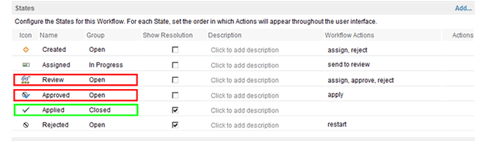

1. **Note:** Add the **Workflow Actions** in the image after you have added the actions in **Step 4**.
2. Add or edit actions. Make entries for **apply**, **approve**, **assign**, **reject**, **restart**, **send to review**, and **start**:
   1. In the **Actions** section, and click **Add**.
   2. Enter a name and brief description for the action.
   3. Select a target state that is appropriate for each state. For **apply**, select **Applied**, for **approve**, select **Approved**, for **assign**, select **Assigned**, for **reject**, select **Rejected**, for **restart**, select **Created**, for **send to review**, select **Review**, and for **start**, select **Created**.
   4. The process templates include a set of icons. Select an icon, or click **Add Icons** and select your own graphics file to use as the icon for the state.
   5. Click **OK**.

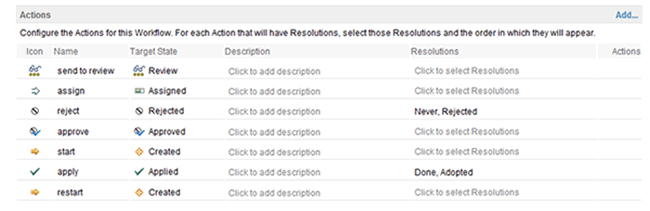

1. **Note:** You add the **Resolutions** in the image in **Step 8**.
2. In the **Transitions** section, the state transition model is displayed. The row headings contain the **From** state, and the column headings contain the **Target** state. Add actions for the states:

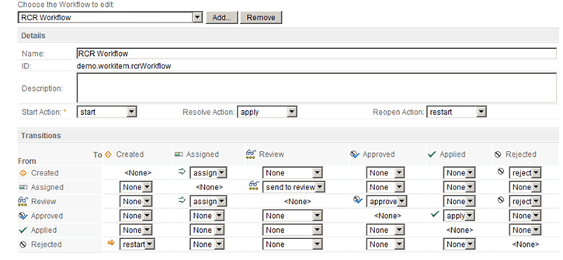

1. In the **Workflow** section, set the main workflow actions:
   1. In the **Start** action field, select **start**.
   2. In the **Resolve** action field, select **apply**.
   3. In the **Reopen** field, select **restart**.
2. Add a resolution:
   1. In the **Resolutions** section, click **Add**.
   2. Enter a name and brief description for the manner in which a work item can be resolved. For example, you might define resolutions such as **Fixed**, **Fixed indirectly**, and **Not a bug**.
   3. Select or add an icon for the resolution, then click **OK**.

To define all resolutions in the workflow, repeat these steps.

1. In the **Actions** section, for each action that can be resolved, select those resolutions and the order in which they are displayed in the work item editor and other places throughout the user interface. To set the order of the resolutions, click **Move Up** and **Move Down** in the **Resolution** table.
2. In the **States** section, for each state, set the order in which to display the available actions in the work item editor and other places throughout the user interface. Select a state. To set the order of the actions, click **Move Up** and **Move Down** in the **Actions** table.
3. Click **Save**.
4. To associate a type category with the new workflow:
   1. In the **Configuration** menu, click **Types and Attributes**.
   2. Select a type that is associated with the type category for which to designate the new workflow.
   3. Select the new workflow, and then click **Save**.

If you change the workflow association for a type category, all work item types that are associated with that category also adopt the new workflow.

You now need to define a work item type that uses this workflow.

**3. Define a work item type called Requirement Change Request**

The next step is to set up a work item type that uses the RCR workflow you set up.

**Procedure**

**Define a work item type called Requirement Change Request:**

1. In the project, open the **Types and Attributes** page:
   1. In the **Team Artifacts** view of the **Work Items** perspective, right-click the project area and select **Open**.
   2. Click the **Process Configuration** tab.
   3. Expand **Project Configuration > Configuration Data > Work Items**, and then click **Types and Attributes**.
2. In the **Work Item Types** section, click **Add**.
3. In the **Add type** window:
   1. In **Name**, enter **Requirement Change Request**.
   2. Create a type category to associate the work item type with. Enter **demo.workitem.workitemType.rcr**.
   3. Click **OK** to create the new work item type, and open it in the **Types and Attributes** page.
4. Select an icon, and click **OK**.
5. Create an alias. Enter **rcr**.
6. Select an editor presentation that defines how the new work item type is displayed in each of the following editors:
   1. Work Item Editor: The default editor for creating and modifying work items. Select **demo.workitem.editor**.
   2. Inline Work Item Editor: The editor for inline work item modification. Select **com.ibm.team.workitem.web.inline.task**.
   3. Lightweight Work Item Creation Dialog: The editor for quickly creating work items. Select **com.ibm.team.workitem.lightweight.editor.section**.
   4. Plan Editor Preview: The editor for viewing and modifying work items inside a plan. Select **com.ibm.team.apt.planPreview.task**.

You can customize the editor presentations on the **Editor Presentations** page.

1. In **Workflow**, select **RCR Workflow**.
2. Click **Save**.

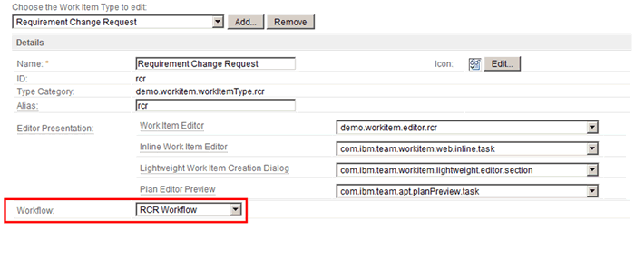

**4. Define the mapping between the change management type and work item type**

The next step is to define the mapping between the change management type and work item type. The type bindings define the type of work items that are made available in OSLC integrations.

**Procedure**

**Configure the Change Management Type binding in RTC:**

1. In the project, open the **Change Management Type Bindings** page:
   1. In the **Team Artifacts** view of the **Work Items** perspective, right-click the project area and select **Open**.
   2. Click the **Process Configuration** tab.
   3. Click **Project Configuration > Configuration Data > Work Items**, and then click **Change Management Type Bindings**.
2. In the **Defect** row, select **Defect**, and then select the state that indicates that this type is ready for testing. Select the state that indicates that this type has reached resolution.
3. In the **Implementation Request** row, select **Requirement Change Request**, and then select the state that indicates that this type is ready for testing.
4. In the **Quality Task** row, select **Task**.
5. In the **Requirement CR** row, select **Requirement Change Request**.

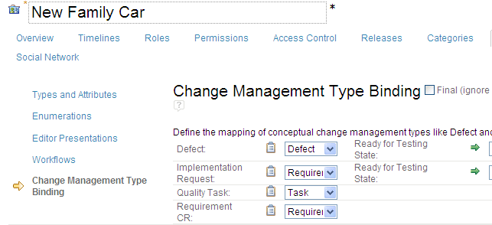

1. Click **Save**.

**5. Configure RTC and Rational DOORS to communicate with one another**

To allow the integration to work correctly, both RTC and the Rational DOORS database must be set up to communicate with one another.

In RTC:

* Set up RTC to allow the connection from Rational DOORS
* Add Rational DOORS to RTC as a friend
* Add Rational DOORS to the Whitelist in RTC
* Associate Rational DOORS with the project in RTC

You must then open Rational DOORS and set it up to allow the connection from RTC.

**Before you begin**

* Get yourself database manager powers or custom user powers to manage the database in Rational DOORS.
* Make sure that Rational DOORS Web Access is running in **https** mode.
* Make sure that you have logged in to Rational DOORS Web Access at least once since it was started.

**Procedure**

**Set up RTC to allow the connection from Rational DOORS:**

1. Log in to RTC as an administrator.
2. Go to the **Application Administration** page for the RTC application, click **Application Administration > Application**, and then, in the **Communication** section in the navigation menu on the left, click **Consumers (Inbound)**.
3. Create a consumer entry for Rational DOORS. Enter a consumer name (for example, DOORS), enter a consumer secret, and then click **Register**. Make a note of the consumer secret. It is used later when you set up Rational DOORS.
4. Rational DOORS is now registered in RTC as a consumer. Navigate to the list of authorized keys, and make a note of the consumer key that has been automatically allocated. It is used later when you set up Rational DOORS.

**Add Rational DOORS to RTC as a friend:**

1. In the navigation menu on the left, click **Friends (Outbound)**, and in the **Friends** pane, click **Add**.
2. Enter a name for the connection (for example, DOORS).
3. Enter the details for the Rational DOORS service. This service is hosted on Rational DOORS Web Access, and the default URL is **https://*hostname*:8443/dwa/public/rootservices**.
4. Enter an **OAuth secret** (for example, DOORS). Make a note of the OAuth secret. It is used later when you set up Rational DOORS.
5. Click **Create Friend**. A green confirmation message is displayed.
6. Click **Next**. Make a note of the Provisional key. It is used later when you configure Rational DOORS to access RTC.
7. Click **Finish**.

**Add Rational DOORS to the Whitelist in RTC:**

1. In the navigation page on the left, click **Whitelist (Outbound)**, and click **Add**.
2. In the **URL Whitelist** pane, enter the URL of the Rational DOORS database. The default URL is **https://*hostname*:8443/**.
3. Click **Add**. A green confirmation message is displayed.

**Associate Rational DOORS with the project in RTC:**

You can create an association between a project area in RTC and a module in Rational DOORS. After you establish the association, you can link RTC artifacts, such as work items and plans, between the project area and objects in the module in Rational DOORS. There are two associations to create.

1. Open the project.
   1. In the **Team Artifacts** view of the Work Items perspective, click **Project areas**.
   2. Select the new project.
2. On the **Overview** page, scroll down to **Associations**, and click **Add**.
3. In **Application**, select the Rational DOORS connection. The name that is displayed is the name you entered in the Friends list.
4. The Rational DOORS Web Access login screen is displayed. Log in.
5. Go back to RTC.
6. In **Association**, select **Provides - Implementation Requests**.
7. In **Artifact Containers**, select the Rational DOORS module you want to work with.
8. Click **OK**, and select the next association.
9. In **Association**, select **Provides - Requirements Change Requests**.
10. In **Artifact Containers**, select the Rational DOORS module you want to work with.
11. Click **OK**, and then click **Save** to save the project.

**Set up Rational DOORS to allow the connection from RTC:**

1. Log in to Rational DOORS as a database manager or a custom user who has the power to manage the database.
2. Right-click the database root, and select the **Remote Services** tab.
3. Add the RTC server to the Server List:
   1. Click **Add**, and enter a name for the connection (for example, RTC).
   2. Enter the URL for the root services of the RTC server.
      * If there was a clean installation of RTC 3.0, enter **https://*hostname*:*port*/ccm/rootservices**.
      * If RTC was upgraded from RTC 2.*x*, enter **https://*hostname*:*port*/jazz/rootservices**.
   3. Enter the consumer key and enter the consumer secret in **OAuth secret**. You made a note of these in **step 3** and **step 4** when you set up RTC.
   4. Click **Register**. The server is added to the list.
4. Add collaboration links from RTC projects to the Rational DOORS database:
   1. In the **Collaboration Links** pane, click **Add**.
   2. Select the server that you registered (**RTC**). If a security warning is displayed, click **Yes**.
   3. The login page to RTC is displayed. Log in.
   4. Select the project you want to access from Rational DOORS, and click **Add**.
   5. Go back to Rational DOORS. The project is displayed in the **Collaboration Links** pane of the **Remote Services** tab.
5. A Consumer Key and OAuth Secret should have been dynamically created when you added Rational DOORS as a friend to RTC earlier. If they have not been created, create a Consumer Key and OAuth Secret for the server:
   1. On the **Local Keys** tab of the Rational DOORS database properties, click **Add**.
   2. Enter the name of the connection (**RTC**).
   3. Enter the friends consumer key and in **OAuth secret**. You made a note of these when you added Rational DOORS to RTC as a friend.
   4. Click **Register**, and then click **OK** to close the database properties.

RTC and Rational DOORS are now configured to communicate with one another.

**6. Define a configuration template in Rational DOORS**

The next step is to define a configuration template in Rational DOORS.

Defining a configuration template uses the Change Management for Rational DOORS functionality that is built into Rational DOORS. The configuration template specifies the project area in RTC, the workflow to use, and the states and actions in RTC that are to be used by Rational DOORS.

For information about Change Management for Rational DOORS, see the [Change Management for Rational DOORS](http://publib.boulder.ibm.com/infocenter/doorshlp/v9/topic/com.ibm.doors.install.doc/topics/doors_int_admin_user.pdf) manual.

**Procedure**

**To define the configuration template:**

1. Open Rational DOORS.
2. Click **Change Management > Define Configuration Templates**. **Step 1** of the **Configuration Template wizard** is displayed.
3. Enter a name for the template.
4. Select **OAuth** as the authentication method.
5. Select your configured RTC project area, and click **Next**. The RTC login screen is displayed. If a **Security Alert** window is displayed, click **Yes**.
6. Log in to RTC. **Step 2** of the **Configuration Template wizard** in Rational DOORS is automatically displayed.
7. Map the RTC workflow states and actions to states and actions in the Requirements Change Management workflow.

**Note:** You must use the internal workflow state and action identifiers, not the names that are displayed in RTC. If you are using the Simple Team Process in the RTC project area, you can find internal workflow state identifiers here: https://*rtc*:9443/ccm/oslc/workflows/*project area ID*/states/*Workflow*, and internal workflow action identifiers here: https://*rtc*:9443/ccm/oslc/workflows/*project area ID*/actions/*Workflow*:

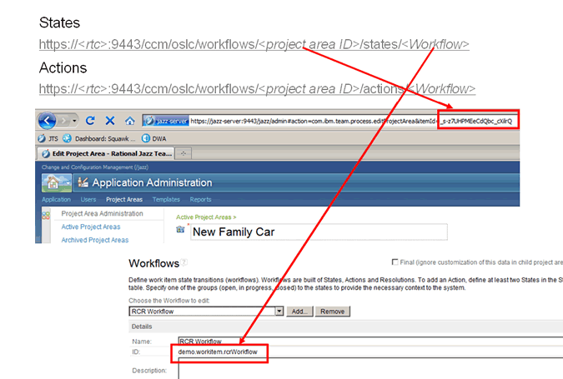

In this example, the URLs are:

* + https://jazz-server:9443/ccm/oslc/workflows/_s-z7UHPMEeCdQbc_cXlrQ/states/demo.workitem.rcrWorkflow
  + https://jazz-server:9443/ccm/oslc/workflows/_s-z7UHPMEeCdQbc_cXlrQ/actions/demo.workitem.rcrWorkflow

When you open these URLs, an XML file is displayed listing the state identifiers and the action identifiers, for example:

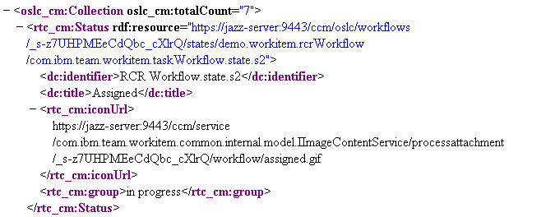

In this example, the state is **Assigned**, which is denoted by the **dc:title**, and the state identifier is **RCR Workflow.state.s2**, which is denoted by the **dc:identifier**.

* + In **Assigned State**, enter the state identifier **RCR Workflow.state.s2**.
  + In **Review State**, enter the state identifier **RCR Workflow.state.s3**.
  + In **Approved State**, enter the state identifier **RCR Workflow.state.s4**.
  + In **Applied State**, enter the state identifier **RCR Workflow.state.s5**.
  + Select **For Rational Team Concert**.
  + In **Apply Action Attribute**, enter the action identifier **RCR Workflow.action.a2**.
  + In **Review Action Attribute**, enter the action identifier **RCR Workflow.action.a3**.
  + In **State Attribute**, enter **rtc_cm:state**.
  + In **RCR Submit Form**, select **Requirement Change Request**.
  + In **Conflicting Proposal Behavior**, select **Take no action**.
  + Clear **Show RCR Recording Report** and **Enable Reject button in DWA**:

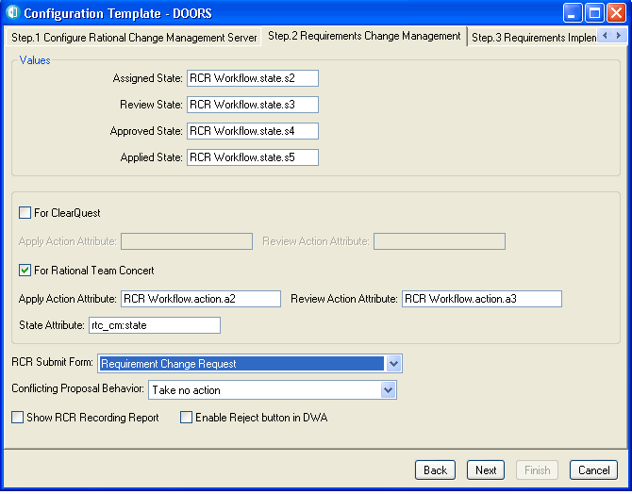

1. Click **Next**. **Step 3** of the **Configuration Template wizard** is displayed.
2. Select **Plan Item** in **Use Submit Form** and **Plan Item** in **Use Add Form**. Plan Item is one of the Change Management Binding Settings in RTC Project Area, and is bound to Story.
3. Click **Next**, leave **Step 4** blank, click **Next**, and then click **Finish**. The new configuration template is created.

**7. Set up the module configuration in Rational DOORS**

To use the integration, you must set up the module in Rational DOORS to use the configuration template.

Set up the module to use both **Requirements Change Requests** and **Implementation Requests**.

**Procedure**

**To configure a module:**

1. Open Rational DOORS.
2. Open the module you want to work with, and click **Change Management > Configure Module**.
3. Select the RTC configuration template. This defines the project in RTC that you will connect to.
4. Set **Integration Status** to **ON**.
5. Select **Enable Requirements Change Management** to use Requirements Change Requests. The related fields can be edited. Leave them selected:
   * **Create RCR Attrs View** creates a view in the module that lists all the Requirements Change Requests that have been implemented against individual objects.
   * **Manage External Links** and **Manage Internal DOORS Links** manage traceability. Rational DOORS has both internal and external links, and they can be managed independently.

**Note:** If you want to use the Implementation Request feature where requirements are sent to RTC for developers to use, then you must consider managing external links. An Implementation Request creates an external link to the work item in RTC. If you are managing external links, you must create an Implementation Request as part of a Requirements Change Request. If you are not managing external links, you can open the module for unmanaged changes and raise the Implementation Request.

1. Select **DOORS Attributes Managed by RCRs**, choose the attributes you want to manage, and click **Apply**.

By default, the integration manages the changes to Object Heading and Object Text. If you want, you can select other attributes (for example, custom attributes such as Priority, Cost, and so on).

1. Select **Enable Requirements Implementation** to use Implementation Requests. The related fields can be edited:
   * Select **Create IR Attrs View** to create a view in the module that lists all the Implementation Requests that have been implemented against individual objects.
   * Clear **Enable Requirements Gathering**.
2. Select **Map Attributes for CM IR Submission**, choose the attributes you want to map, and click **Apply**.

The Rational DOORS attributes are listed. Associate the attributes with RTC values by entering the RTC values in the **CM Attribute** column. By default, Object Heading is mapped to title, and Object Text to description. Custom attribute values must match the available values in RTC. Rational DOORS does not automatically check the associations; make sure you check them manually.

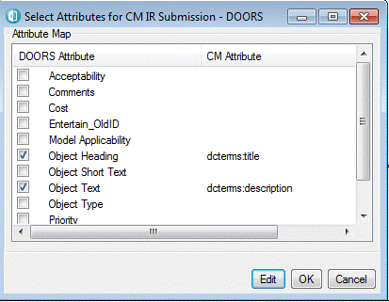

1. Click **OK**, and then click **Save**.

Module configuration is complete.

Now that you have configured a module in Rational DOORS, you can proceed to use the integration.

# 5.Backup

## 5.1 Backup of WebSphere profiles & Setup files.

**Backing up WebSphere Application Server profiles (manageprofiles command)**

You can back up your WebSphere® Application Server profiles with the **manageprofiles** command before you upgrade a server or for routine system backups in disaster recovery procedures.

**Before you begin**

Ensure that the following components are stopped:

* WebSphere Application Server. See [Stopping the WebSphere Application Server on Windows](http://www.ibm.com/support/knowledgecenter/en/SS9JLE_8.2.1/com.ibm.itamesso.doc_8.2.2/Installation_Guide/tasks/stopping_middleware.html?view=kc#start_ims_on_cluster).
* (Network deployment) Node agent
* (Network deployment) Deployment manager
* IBM® HTTP Server

**Procedure**

1. Open the command prompt.
2. Browse to the <was_home>\bin directory. For example, type:

cd <was_home>\bin

For example:

cd c:\Program Files\IBM\WebSphere\AppServer\bin

1. Use the WebSphere Application Server **manageprofiles** command with the **backupProfile** parameter.

**manageprofiles.bat** **-backupProfile** **-profileName** *<profile_name>* **-backupFile** *<backupFile_name>*

For example:

**Stand-alone**

manageprofiles.bat **-backupProfile** **-profileName** AppSrv01 **-backupFile** c:\backup\AppSrv01yymmdd.zip

**Network deployment**

manageprofiles.bat **-backupProfile** **-profileName** Dmgr01 **-backupFile** c:\backup\Dmgr01yymmdd.zip

Restore the WebSphere® Application Server profiles from a backup if you must recover from a previously backed up working WebSphere Application Server profile.

**Before you begin**

Ensure that the following servers are stopped:

* WebSphere Application Server
* Node agents
* IBM® HTTP Server

Be sure that the <was_home>/profiles directory does not contain a similar folder name as the profile to be restored. If a duplicate exists, you can delete the profile with the **manageprofiles** command or move the folder to another location.

**Procedure**

1. In a command prompt, browse to the <was_home>\bin directory. Type cd <was_home>\bin.

For example: cd c:\Program Files\IBM\WebSphere\AppServer\bin

1. Restore the profile. Type **manageprofiles** **-restoreProfile** **-backupFile** *<backup_file_location>*. For example

**manageprofiles** **-restoreProfile** **-backupFile** c:\backup\AppSrv01yymmdd.zip

The **manageprofiles** command-line tool always restores to the same path from which the profile was backed up.

1. Verify that the profile is restored. Browse to the <was_home>\profiles directory. For example: <was_home>\profiles\AppSrv01. If the profile is restored successfully, a folder for the restored profile is displayed.

**Results**

You restored the WebSphere Application Server profile.

If you are performing this task as part of a server restoration procedure, do not start the profile. Determine whether you must restore the database first.

## 5.2 Back up of Rational Doors.

Use standard file system backup tools to back up the disk. Use IBM® Rational® DOORS® archives to make a backup of a module, a project, or information about users and groups to protect against accidental data loss. For example, if a user deletes and purges a project, you can restore the project from your archive.

To protect the data in your Rational DOORS database against the failure of the disk on which it is stored, take regular backups of the disk. For Rational DOORS data, you can do full or differential backups. If you do differential backups, make sure that you do a full backup at least once a week. Do not use incremental backups. Restoring data from incremental backups requires complex steps to restore previous backups. If there is a disk hardware error, you can restore the entire disk from your backups.

Before you back up your disk:

1. Make sure that all users are logged out of Rational DOORS. Most backup tools do not back up files that are open. If files are skipped because users are accessing the database, your backup might capture inconsistent data.
2. If you are using Rational DOORS Web Access, stop Rational DOORS Web Access, as described in [Running Rational DOORS Web Access](http://www.ibm.com/support/knowledgecenter/en/SSYQBZ_9.6.0/com.ibm.rational.dwa.install.doc/topics/c_rundoorswebaccess.html?view=kc).
3. Stop the Rational DOORS database server, as described in [Stopping the database server](http://www.ibm.com/support/knowledgecenter/en/SSYQBZ_9.6.0/com.ibm.doors.administering.doc/topics/t_stoppingdbserver.html?view=kc).

After you back up your disk:

1. Start the Rational DOORS database server, as described in [Managing the Rational DOORS database server](http://www.ibm.com/support/knowledgecenter/en/SSYQBZ_9.6.0/com.ibm.doors.administering.doc/topics/c_managedoorsdbs.html?view=kc).
2. If you are using Rational DOORS Web Access, start Rational DOORS Web Access, as described in [Running Rational DOORS Web Access](http://www.ibm.com/support/knowledgecenter/en/SSYQBZ_9.6.0/com.ibm.rational.dwa.install.doc/topics/c_rundoorswebaccess.html?view=kc).

If you are using Rational DOORS Web Access with Rational Insight or TRS consumer applications, such as IBM Rational Engineering Lifecycle Manager, back up the Derby database that is used with the integration when you back up your Rational DOORS database. The default location for the Derby database is C:\Program Files (x86)\IBM\Rational\DOORS Web Access\9.*version*\server\festival\derby\. If you need to restore your Rational DOORS database, restore the Derby database at the same time to ensure data consistency